**Movement Competency Training**

10:00am – 12:00pm

Google Meet joining info Video call link: [https://meet.google.com/kzy-wcuy-nyz](https://meet.google.com/kzy-wcuy-nyz?fbclid=IwAR3OErpsWmNONAFtRIi-KHryQjgG3nqCm-6VCkLeNoq5bhRpon1x8Rgmo74)

**Module No. 1**

**Week 2**

STRETCHING, TWISTING, SQUATS, LUNGE, BALANCING

**OVERVIEW OF THE TOPIC**

In this module, you will learn and understand the importance of Core training specifically in most of the physical activities that we do in our everyday life. The Core muscles provide support in terms of mobility and stability when our body moves.

Training your core muscles which follows the training principles of progression, regression and overload will enhance and also improve the efficiency of your movement.

**Core Training**

Core training is considered as the strengthening and conditioning of the core muscles surrounding the mid-section of our body—the abdomen, hips, pelvis, and lower back. These muscles wrap and protect the spine which is responsible for stabilizing and balancing the body during movement. And also, core training refers to core stabilization or balance training.

**Fundamental Movement Skills**

* The Fundamental Movement Skills (FMS) are some of the most common actions from childhood to adulthood.
* FMS consists of three skills groups that define physical literacy which are the non-locomotor, locomotor, and manipulative skills.

1. **NON-LOCOMOTOR**

* Any movement that does not travel, but uses the available space in any direction or movement organized around the axis of the body (axial movement); bending, twisting, stretching, and swinging is an examples of axial movement.

Ex. Stretching, twisting, squats, lunge, balancing.

1. **LOCOMOTOR**

* Locomotor movement skills are those in which the body is moved in one direction, or a combination of directions, from one point to another. Activities such as walking, jogging, moving forwards, backward, side- shuffling, skipping, running, jumping, hopping, and leaping are considered fundamental locomotion movements.

1. **MANIPULATIVE**

* Manipulative movements are movements that involve the use of a body part like hands or feet to move or manipulate an item. Manipulative movements can include gross motor skills, like kicking or bouncing a ball, or fine motor skills, like writing or coloring. Manipulative motor skills are often important in sports.

**Assessments of Physical Activity and Readiness**

* Besides your movement skills competency, checking your current levels of activity and fitness is crucial to determine the readiness of your body for physical activities.
* Most of the Assessments being done are the PAR-Q where the results of this test will determine if you have a medical problem and need to address it as soon as possible.
* This assessment will be done before participating in the fitness test or any physical activity.

**Activity 1: Hidden Word**

1. MANIPULATIVE
2. LOCOMOTOR
3. CORE
4. LUNGE
5. WALK

**Activity 2: Point the Word**

1. Locomotor – Locomotor movement skills are those in which the body is moved in one direction, or a combination of directions, from one point to another. Activities such as walking, jogging, moving forwards, backward, side- shuffling, skipping, running, jumping, hopping, and leaping are considered fundamental locomotion movements.

**Activity 3: Picture Analysis**

1. The woman is working out her waist by planking. She works out to get rid of the belly fat.
2. The lady is practicing leg workouts. The lady performing lunges to strengthen her hip and leg muscles
3. A mountain climber uses a safety cord to keep himself safe. Mountain climbing is a thrilling but risky activity, therefore safety comes first.
4. Baseball player successfully catches a baseball in order to win.

**Activity 4: Think and Share**

**Core training** is defined as the strengthening and conditioning of the muscles that surround our midsection—the belly, hips, pelvis, and lower back. These muscles wrap around and protect the spine, which is in charge of maintaining and balancing the body when moving. Core training can also refer to core stabilization or balance training.

The Fundamental Movement Skills (FMS) are some of the most common actions from childhood to adulthood. FMS consists of three skills groups that define physical literacy which are the non-locomotor, locomotor, and manipulative skills.

**Non-Locomotor**

* Any movement that does not travel but uses the available space in any direction or movement arranged around the axis of the body; bending, twisting, stretching, and swinging are examples of axial movement.

**Locomotor**

* Locomotor movement abilities are those in which the body moves in one direction or a mix of directions from one location to another. Walking, jogging, going forwards and backwards, side-shuffling, skipping, running, jumping, hopping, and leaping are examples of essential locomotor actions.

**Manipulative**

* Manipulative movements are those that entail the use of a bodily part, such as the hands or feet, to move or manipulate an item. Manipulative motions can involve big motor abilities such as kicking or bouncing a ball as well as fine motor skills such as writing or drawing. In sports, manipulative motor abilities are frequently required.

**Activity 5: Guide Questions**

**Directions**: Read and answer the following questions:

1. What are the aspects of an individual that will improve by understanding core training? How does it develop each aspect?

* Training your core muscles which follows the training principles of progression, regression and overload will enhance and also improve the efficiency of your movement.

1. Why is it important to identify the physical activity level of readiness?

* In addition to your movement skills proficiency, examining your current levels of activity and fitness is critical to determining your body's preparedness for physical activities.
* The PAR-Q is used for the majority of assessments, and the results of this exam will decide if you have a medical concern that has to be addressed as soon as feasible.
* This evaluation will take place before to participating in the fitness test or any physical activity.

1. How do core training can improve your stability and mobility?

* You may increase your stability by repeating exercises and improving mobility during core training so that your muscles can develop to such an extent.

**Activity 6: Table Completion**

Link for Google form will be sent to group chat messenger.

**Directions**: Complete the table below by identifying if the movement is non-locomotor, locomotor or manipulative movement:

|  |  |
| --- | --- |
| Movement | Type of Movement |
| 1. Kicking | Manipulative |
| 2. Catching | Non-locomotor |
| 3. Climbing | Locomotor |
| 4. Squat | Non-locomotor |
| 5. Lunge | Non-locomotor |
| 6. Balancing | Manipulative |
| 7. Dribbling | Manipulative |
| 8. Swimming | Locomotor |
| 9. Running | Locomotor |
| 10. Wheeling | Locomotor |

**Module No. 2**

**Week 3**

**POSTURE AND CORE STABILITY**

Core stability muscles, or postural muscles, are the deep muscles in your abdomen, pelvis, and back. They act as a corset or scaffolding holding you together rather than moving your trunk. It is important to have good postural muscles to help maintain a good posture. In the abdomen, there are four layers of muscles.

And also, there are syndromes that are developed when the muscles of your shoulders, neck, and chest are out of balance — some too weak and some too tight.

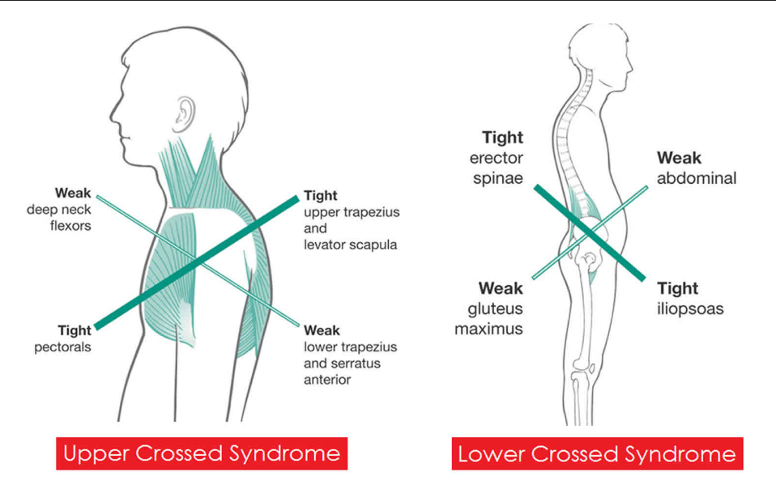

**Anatomy of the Core**

* The core is the group of the trunk and hip muscles that surround the spine, abdominal viscera, and hip. Core muscles are essential for proper load balance within the spine, pelvis, and kinetic chain. They spare the spine from excessive load and are essential for lad transfer between the upper and lower body.
* Abdominal, gluteal, hip girdle, paraspinal, and other muscles work in concert to provide this needed spinal stability.
* Having a strong, stable core helps us to prevent injuries and allows us to perform at our best.
* There is also an upper quadrant core (glenohumeral and scapulothoracic joints) and a lower quadrant core (hip and trunk)
* Core Trunk Muscles: Abdominals; thoracolumbar; lumbar and lateral thoracolumbar muscles
* Core Hip Muscles: Hip flexors, extensors, abductors, adductors, and rotators.
* Your core stabilizers are made up of 3 main muscles groups — your **Transverse** **Abdominals** (Deep Abs); your **Pelvic Floor** (a sling from your pubic bone to tail), and **Multifidus**, (small segmental muscles lining your spine)
* Mobilizers of the spine are the more superficial muscles that cross over multiple joints so that when they contract, they move many joints at once:
* the rectus abdominus,
* obliques,
* lateral portions of erector spinae,
* latissimus dorsi
* quadratus lumborum.

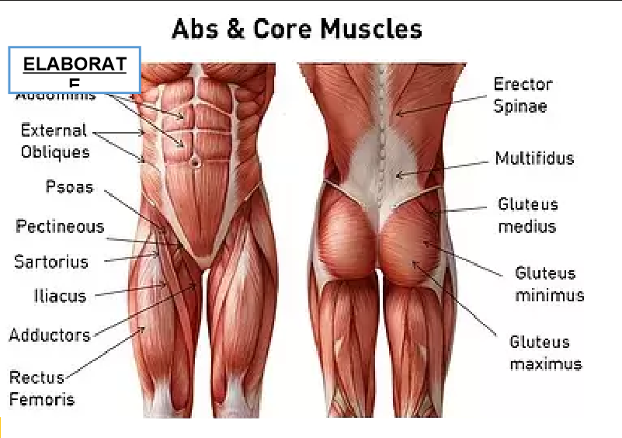

**Activity 1: Crossword Puzzle**

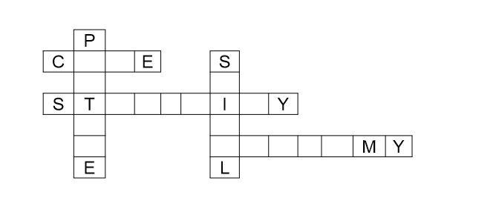

* Core
* Posture
* Stability
* Spinal
* Anatomy

**Activity 2: Point the Word**

**Directions**: Using the information you got from the previous activity, try to provide answers to the questions below (maximum of two sentences per item).

1. What are the words you've got from activity 1?

* Core
* Posture
* Stability
* Spinal
* Anatomy

1. How are those words associated with Posture and Core stability?

* It is connected because it is linked and contains comparable terms. The deep muscles in your belly, pelvis, and back are known as core stability muscles or postural muscles. Rather of shifting your trunk, they work as a corset or scaffolding to keep you together. To maintain excellent posture, it is necessary to have strong postural muscles. There are four layers of muscles in the abdomen.

**Activity 3: Think and Share**

**Directions**: Read and understand the concepts below. You can raise questions that you

want to clarify where students and teacher must collaborate in this part.

Transverse Abdominals (Deep Abs), Pelvic Floor (a sling from your pelvic bone to tail), and Multifidus are the three primary muscle groups that comprise your **CORE STABILIZERS** (small segmental muscles lining your spine)

**MOBILIZERS** of the spine are the more superficial muscles that span over many joints, allowing them to move several joints at once when they contract:

* the rectus abdominus,
* obliques,
* lateral portions of erector spinae,
* latissimus dorsi
* quadratus lumborum.

**Activity 4: Guide Questions**

**Direction**: Answer the following question base on the previous activity given.

* 1. What are the benefits of having a good posture? How does it help an individual in his/her everyday task?
* There are several benefits to having good posture, including increased flexibility and less chance of injury. It also helps on a daily basis. To maintain excellent posture, it is necessary to have strong postural muscles. Injury can be avoided by maintaining proper posture, particularly in the back, shoulders, arms, and wrists. Setting up an ergonomically suitable workstation is vital for preserving the health of your back, shoulders, arms, and wrists if you work at a desk all day, especially if you write on a keyboard. Your workstation should ideally be slightly below elbow level so that your forearms and wrists remain parallel to the floor when typing.
  1. Why is it important to learn the different core muscles?
* It is important to have firm postural muscles in order to maintain proper posture. A strong, solid core in the abdomen helps us avoid injuries and perform at our best. Spinal injuries are commonly caused by a combination of bending forward, side to side, or extreme rotation. Back injuries are frequently the result of a series of incidents combined with poor mechanics.

**Activity 5: Quiz Table**

Link for Google form will be sent to group chat messenger.

**Directions**: Identify if the given core muscle below has a function of being a stabilizer or mobilizer muscle.

|  |  |
| --- | --- |
| Core Muscles | Function |
| 1. Rectus abdominus | Mobilizer |
| 2. Latissimus dorsi | Mobilizer |
| 3. Pelvic Floor | Stabilizer |
| 4. Transverse Abdominals | Stabilizer |
| 5. Multifidus | Stabilizer |
| 6. Erector spinae | Mobilizer |
| 7. Quadratus lumborum | Mobilizer |
| 8. Erector spinae | Mobilizer |
| 9. Rectus Femoris | Mobilizer |
| 10. Sartorius | Mobilizer |

**Module No. 3**

**Week 4**

**Bracing the Core**

* Bracing your core requires you to **engage your entire trunk — abdominals, pelvic floor, diaphragm, and spinal erectors — to create the stability required to lift safely**. It also ensures an effective force transfer through your body to move the weight.

**Bracing Versus Hollowing**

* Hollowing exercises, which concentrate on the contraction of local muscles, draw the belly button toward the lumbar spine. On the other hand, bracing exercises, which contract the local and global muscles at the same time, are performed by pushing the abdomen out externally

**Exercise Progression and Regression**

* An exercise regression is simply an approach to decrease the demand for exercise or movement. Conversely, a progression does the opposite by increasing the demand incrementally through minor changes. traditional push-up.

**Non-locomotor Skills**

* Non-locomotor skills include: **bending, twisting, curling, and swaying motions involving a wide range of body joints**. Non-locomotor skills include stretching, bending, twisting, and hand clapping. They consist of any motion of the body that doesn't result in traveling from one place to another. Turning, foot tapping and winking are examples as well.

**Training Guidelines**

How much physical activity is recommended?

WHO guidelines and recommendations provide details for different age groups and specific population groups on how much physical activity is needed for good health.

**Children and adolescents aged 5-17 years**

* should do at least an average of 60 minutes per day of a moderate-to-vigorous intensity, mostly aerobic, physical activity, across the week.
* should incorporate vigorous-intensity aerobic activities, as well as those that strengthen muscle and bone, at least 3 days a week.
* should limit the amount of time spent being sedentary, particularly the amount of recreational screen time.

**Adults aged 18-64 years**

* should do at least 150-300 minutes of moderate-intensity aerobic physical activity;
* or at least 75-150 minutes of vigorous-intensity aerobic physical activity; or an equivalent combination of moderate- and vigorous-intensity activity throughout the week
* should also do muscle-strengthening activities at moderate or greater intensity that involve all major muscle groups on 2 or more days a week, as these provide additional health benefits.
* may increase moderate-intensity aerobic physical activity to more than 300 minutes, or do more than 150 minutes of vigorous-intensity aerobic physical activity, or an equivalent combination of moderate-and vigorous-intensity activity throughout the week for additional health benefits.
* should limit the amount of time spent being sedentary. Replacing sedentary time with physical activity of any intensity (including light intensity) provides health benefits, and
* to help reduce the detrimental effects of high levels of sedentary behavior on health, all adults and older adults should aim to do more than the recommended levels of moderate- to vigorous-intensity physical activity

**Importance of Core Training:**

Core exercises train the muscles in your pelvis, lower back, hips, and abdomen to work in harmony. This leads to better balance and stability, whether on the playing field or in daily activities. In fact, most sports and other physical activities depend on stable core muscles.

**Activity 1: "MOVE IT!"**

**Directions**: Look at the figures below. Are you familiar with these? Try matching the terms on the right with each figure.

* Sit-up crunch
* Cobra
* Back Extension
* Plank
* Standing wood chop
* Side plank

**Activity 2: "WHICH IS WHICH?"**

**Directions**: Using the information you got from the previous activity and your previous knowledge about basic exercises, identify which exercises enhance your core strength.

* Leg raises
* Neck Rotation
* Side lunge
* Side leg raise
* Face pull

**Activity 3: Read, Think and Share**

**Directions**: Read and understand the concepts below. You can raise questions that you want to clarify where students and teachers must collaborate in this part.

**Bracing the Core**

* To produce the stability needed to lift properly, bracing your core needs you to activate your entire trunk — abdominals, pelvic floor, diaphragm, and spinal erectors. It also guarantees that the weight is moved with effective force transmission through your body.

**Bracing Versus Hollowing**

* Hollowing exercises, which focus on local muscular contraction, pull the belly button toward the lumbar spine. Bracing exercises, on the other hand, contract both local and global muscles at the same time by pulling the abdomen outwards.

**Exercise Progression and Regression**

* An exercise regression is simply a method of reducing the need for exercise or movement. A progression, on the other hand, performs the opposite by gradually raising demand through modest modifications. conventional push-up

**Non-locomotor Skills**

* Bending, twisting, curling, and swaying actions involving a wide variety of bodily joints are examples of non-locomotor abilities. Stretching, bending, twisting, and hand clapping are examples of non-locomotor abilities. They include any movement of the body that does not result in movement from one location to another. Turning, tapping the foot, and winking are further instances.

**Importance of Core Training:**

Core exercises teach your pelvic, lower back, hips, and abdominal muscles to operate together. This results in improved balance and stability, whether on the field or in daily activities. Most sports and other physical pursuits, in fact, rely on strong core muscles.

**Activity 4: Synthesizing Ideas**

Guide Questions:

1. What is the relationship between Core Training and Non-locomotor Training/Activities?

* Core Training concentrates on the abdominals, pelvic floor, diaphragm, and spinal erectors, whereas Non-locomotor Training involves a wide range of physical joints, such as bending, twisting, curling, and swaying activities.

1. How does Core Training affect the overall well-being of an individual?

* Core Training encourage your pelvic, lower back, hip, and abdominal muscles to work in unison. This improves balance and stability, whether on the field or in everyday tasks. In reality, most sports and other physical activities rely on strong core muscles.

1. What is the importance of the topic amidst the pandemic?

* To exercise because it influences the natural state of the body. Additionally, regular physical activity has been demonstrated to improve the immune system. Reducing drug usage has also been linked to an increase in the body's ability to fight illness.

**Activity 5: "Work It! Design your own Training Program"**

**Directions**: Try working with a partner. Consider your age, preferred training program intensity, equipment, and diet. Design your own training program following the table below:

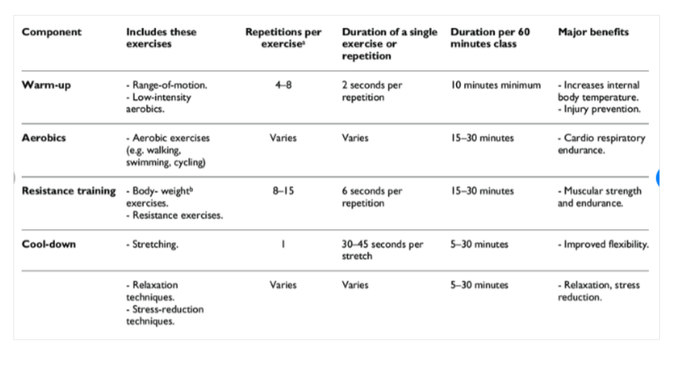

* 1. Warm up exercise 10 mins (head rotation, leg stretches, shoulder stretches, etc)
  2. Push up 3 x 15
  3. Lunges 3 x 15
  4. Dumbbell rows 2 x 20
  5. Burpess 3 x 12
  6. Side planks 3 x 12
  7. Glute bridge 3 x 12
  8. Planks 1:30 min
  9. Shoulder Barbell press 3 x 12 10 8
  10. Machine Shoulder press 3 x 12
  11. Seated Hammer Curls 3 x 12 15- lbs
  12. Machine Preacher Curls Drop Set 3 x 12
  13. Declined sit ups 3 x 12
  14. Cable Rope Front Raise 3 x 12 30-40 lbs
  15. Leg Raises ( w/ pulse up ) 3 x 12
  16. Long arm Crunch 3 x 15
  17. Arnold press 3 x 12 25 lbs
  18. Standing Rear Delts Fly - 4 x 15 15 lbs

**Module No. 4**

**Week 5**

Designing a fitness training plan that's tailored to your personal goals will make you more likely to succeed. The key to designing an effective training plan is determining your goals, choosing the right kind of exercises, and tracking your progress along the way. By doing these things and sticking to your plan, you'll be on your way to achieving your fitness goals.

**PART I: Determining Your Goals**

1. Make a list of your personal fitness goals. Organizing your goals on paper will make it easier to design a training plan based on them. Take time to really think about what you want to achieve with your training plan.
2. Come up with a realistic timeline for achieving your goals. The timeline for your fitness training plan depends on what your specific goals are. Establishing a timeline can make it easier to schedule your workouts and stick to your plan.
3. Measure your current fitness level. Before you design your fitness training plan, it's a good idea to figure out what level of physical fitness you're starting at. Then, you can compare your stats along the way to your starting point and see how much progress you've made.
4. Make dietary changes to help yourself meet your fitness goals. While routine exercise can help you meet your goals, you may also want to adopt a healthier diet, especially if you're trying to lose weight or put on muscle mass. Eating healthier foods will give you more energy for your workouts, and it will help you see faster results.

**PART II: Designing Your Workouts**

1. Include 5-10 minutes of warm-up stretches before your workouts. Do dynamic stretches that move the muscles you plan on working out through their full range of motion. Try lunges, arm circles, high kicks, or marching to help get your blood flowing and your heart pumping.
2. Do moderate and vigorous aerobic exercises if your goal is to lose weight. Including 150-300 minutes of moderate and vigorous aerobic exercise a week in your fitness training plan can help you achieve your weight-loss goal.
3. Do weight-training exercises if your goal is to gain muscle mass. Thirty minutes of weight-training exercises 2-3 times a week can help build your muscles and make them stronger.
4. Do both aerobic and weight-training exercises if your goal is overall fitness. Including both aerobic and weight-training exercises in your fitness training plan can help you be a healthier person overall. If your goals don't require you to prioritize one form of exercise over the other, then do a balance of both.
5. Balance your training plan by doing different exercises. When you're designing your training plan, including a variety of exercises instead of just 1 or 2. Doing a bunch of different exercises can help work out different parts of your body and prevent your muscles from getting strained because of overuse.
6. Start with low-intensity workouts and progress slowly.[17] When you're first starting out with your fitness training plan, it's important that you start slowly with lower- intensity exercises so you don't injure yourself. As you get stronger, you can gradually increase the intensity of your exercises.
7. Include time for recovery in your plan. Giving your body time to recover after your workouts lets your muscles repair themselves, and it also helps prevent injury. Give your muscle groups at least 1-2 days to recover before you work them out again.

**PART III: Tracking Your Progress**

1. Log your workouts so you know how much you're exercising. Keeping track of when you're working out will tell you whether or not you're sticking to your fitness plan and being consistent. You can also use your log to help you figure out which exercises are working and which ones aren't, and also to see how much you're progressing with your workouts.
2. Weigh yourself once a week. If one of the goals of your fitness training plan is to lose weight or gain muscle mass, weighing yourself on a scale will help you track your progress.
3. Keep a journal about how you feel physically and emotionally. If your fitness goal is to feel better about yourself or feel healthier in general, journaling your thoughts can help you track your progress. Take time every day or even just once a week to write down how you're feeling.
4. Adjust your fitness training plan as needed. Use the information you're gathering in your log and on the scale to determine whether or not your training plan is working. If you're not seeing the results you were hoping for, you may need to increase the intensity and duration of your workouts.

What are the benefits of using a personal program?

Simply put, setting goals and having a strategy in place will dramatically increase your chances of achieving your goals.

If your plan has been put together properly you should really be getting the most out of your workouts, which is especially important if you are looking to achieve your goals in a limited amount of time.

Having a plan in place will also allow you to measure your progress as you go along, so you can see whether you are on track.

**Activity 1: "WHAT AM l?"**

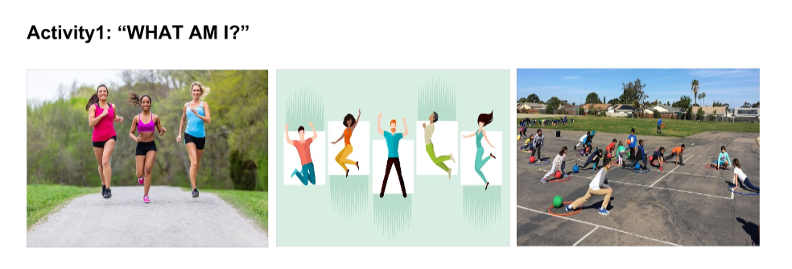

**Social Outdoor Traning**

**ACTIVITY 2: REBUS**

**Directions**: Unlock the hidden word by debunking the rebus puzzle below:

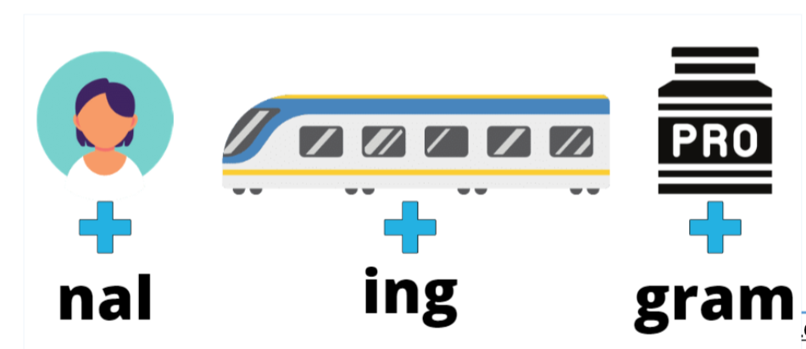

**Personal Trainning Program**

**Activity 3: Read, Think and Share**

**Directions**: Read and understand the concepts below. You can raise questions that you want to clarify where students and teacher must collaborate in this part.

Designing a fitness training plan that is targeted to your specific goals will increase your chances of success. The key to creating a successful training plan is to identify your goals, select the appropriate activities, and measure your progress along the way. You'll be well on your way to reaching your fitness objectives if you accomplish these things and adhere to your plan.

**PART I: Determining Your Goals**

1. Create a list of your own fitness objectives. Putting your goals on paper will make it easier to create a training plan around them. Take the time to consider what you want to accomplish with your training strategy.
2. Create a timetable for accomplishing your objectives. The timing for your fitness training plan is determined by your unique goals. Setting a timetable will help you schedule your workouts and stay on track.

**PART II: Designing Your Workouts**

1. If you want to reduce weight, do moderate to strenuous aerobic activities. Incorporating 150-300 minutes of moderate to strenuous aerobic activity each week into your fitness training program can assist you in reaching your weight-loss target.
2. If you want to build muscular mass, use weight-training activities. Weight-training workouts for 30 minutes, 2-3 times per week, can help grow and strengthen your muscles.

**PART III: Tracking Your Progress**

1. Once a week, weigh yourself. Weighing yourself on a scale may help you track your progress if one of your fitness training goals is to reduce weight or develop muscle mass.
2. Keep a diary of your bodily and emotional feelings. Journaling your thoughts might help you measure your progress if your fitness aim is to feel better about yourself or to feel healthier in general. Take some time each day, or even once a week, to write down how you're feeling.

**Activity 4: Synthesizing Ideas**

Guide Questions:

1. What is Personal Training Program all about?

* A personal trainer's area of work focuses on preventive and entails improving aspects of health and fitness for the general, healthy population or those cleared for exercise. Simply said, defining goals and developing a strategy will significantly boost your chances of success.

1. Why do you think familiarizing oneself with this is important?

* It is important to immerse yourself in your training and become well acquainted with it. This is the stage when you will do it if you have the confidence and will to do so. In this phase, you must do and exercise in order to achieve your goal. It is essential to actively exercise throughout your full health matters more at least once before exercising to prevent injuries. At this point, you may see changes in your body, which is natural because they are the consequence of your hard work.

1. How do the three parts of designing a personal training program affect one another?

* Creating a fitness training plan that is targeted to your specific goals will increase your chances of success. The key to creating a successful training plan is to identify your goals, select the appropriate activities, and measure your progress along the way. You'll be well on your way to reaching your fitness objectives if you accomplish these things and adhere to your plan.

**Activity 5: "Work It! Design your own Training Program"**

**Directions**: Try working with a partner. Consider your age, preferred training intensity, equipment, and diet. Design your own training program following t below:

Make use of the table below as your guide on making your own Training Program:

|  |  |  |  |  |  |  |  |  |  |
| --- | --- | --- | --- | --- | --- | --- | --- | --- | --- |
| **WORKOUT CHART** | | | | | | | |  | |
| Structure your weekly weight training program. |  |  |  |  |  | [42] |  |  | |
|  |  |  |  |  |  |  |  |  |  |
| **WEEK #1** | / 1 / | to | / 7 / | |  | **NAME** |  | | |
| **GOALS: Gain Strenght** |  |  |  |  |  |  |  |  |  |
|  |  |  |  |  |  |  |  |  |  |
|  |  |  |  |  |  |  |  |  |  |
| **WARM UP** |  |  |  |  |  |  |  | DAYS: |  |
| **ACTIVITY** | | | **SETS** | **REPS** | **TIME** | **DIST** | **INTENSITY\*\*** | **NOTES** |  |
| Side Reach | | | 10 | 2 | 20 mins | 2 | Mild |  | |
| Knees Lift | | | 15 | 2 | 25 mins | 2 | Mild |  | |
| Squat To Raised Heel | | | 10 | 2 | 20 mins | 2 | Mild |  | |
|  |  |  |  |  |  |  |  |  |  |
| **CORE BODY - STRENGTH TRAINING** |  |  |  |  |  |  |  | DAYS: |  |
| **EXERCISES** | | | **SETS** | **REPS** | **WEIGHT** |  | **REST TIME** | **NOTES** |  |
| Glute Bridge | | | 15 | 3 | 10 kg |  | 4 mins |  | |
| High Plank | | | 2 | 2 mins | 8 kg |  | 4 mins |  | |
| Superman pull | | | 15 | 2 | 10 kg |  | 4 mins |  | |
|  |  |  |  |  |  |  |  |  |  |
| **UPPER BODY - STRENGTH TRAINING** |  |  |  |  |  |  |  | DAYS: |  |
| **EXERCISES** | | | **SETS** | **REPS** | **WEIGHT** | **1RM\*** | **REST TIME** | **NOTES** |  |
| **Biceps Curls and Hammer Curls** | | | 15 | 3 | 10 kg |  | 4 mins |  | |
| **Assisted Pull-Ups and Dips** | | | 15 | 3 | 8 kg |  | 4 mins |  | |
| **Chest Press** | | | 20 | 2 | 10 kg |  | 4 mins |  | |
| Push ups | | | 25 | 2 | 10 kg |  | 6 mins |  | |
| **Bent-Over Rows** | | | 15 | 3 | 8 kg |  | 4 mins |  | |
| Dumbbell curls | | | 15 | 3 | 10 kg |  | 10 mins |  | |
| Triceps dip | | | 15 | 3 | 10 kg |  | 4 mins |  | |
|  |  |  |  |  |  |  |  |  |  |
| **LOWER BODY - STRENGTH TRAINING** |  |  |  |  |  |  |  | DAYS: |  |
| **EXERCISES** | | | **SETS** | **REPS** | **WEIGHT** | **1RM\*** | **REST TIME** | **NOTES** |  |
| Dumbbell Lunge | | | 15 | 3 | 8 kg |  | 4 mins |  | |
| Hip Thruster | | | 15 | 3 | 10 kg |  | 6 mins |  | |
| Weighted Step-Up | | | 20 | 2 | 10 kg |  | 4 mins |  | |
| Barbell Jammer Press | | | 12 | 3 | 8 kg |  | 10 mins |  | |
| Dumbbell Shoulder Squat | | | 15 | 3 | 8 kg |  | 10 mins |  | |
| Bulgarian Split Squat | | | 15 | 3 | 10 kg |  | 6 mins |  | |
| Side Lunge | | | 20 | 2 | 10 kg |  | 4 mins |  | |
|  |  |  |  |  |  |  |  |  |  |
| **COOL DOWN** |  |  |  |  |  |  |  | DAYS: |  |
| **ACTIVITY** | | | **SETS** | **REPS** | **TIME** | **DIST** | **INTENSITY\*\*** | **NOTES** |  |
| Reclining Butterfly Pose | | | 15 | 3 | 15 mins |  | Mild |  | |
| Upper body stretch | | | 15 | 3 | 15 mins |  | Mild |  | |
| Head-to-Knee Forward Bend | | | 20 | 2 | 15 mins |  | Mild |  | |

**Module No. 5**

**Week 6**

Movement competencies are essential to participation in physical activity. If movement competencies are not developed and nurtured from a young age, this can lead to inactivity and the health and social problems linked to inactivity. The following graphic provides examples of how movement competencies set a foundation for participation in different physical activities.

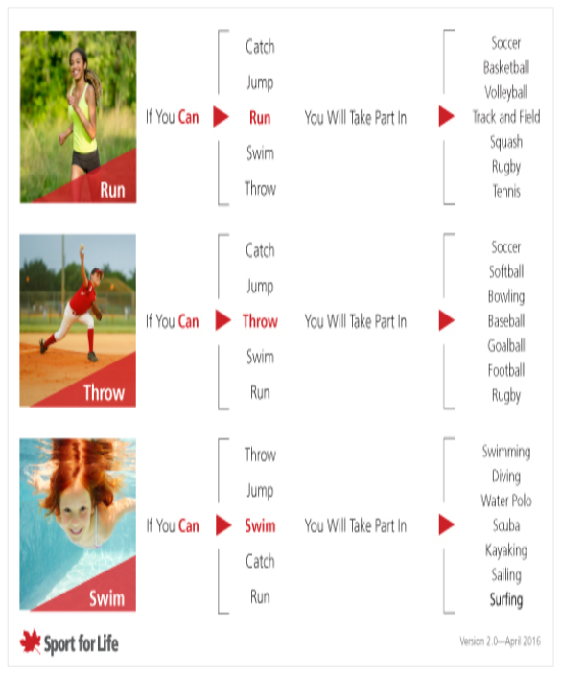

We divide movement competencies into more specific skills including: **SENDING, TRANSPORTING, RECEIVING, AND BODY CONTROL**.

**Sending** includes how a child moves or sends an object away from them. This can include throwing, kicking, head butting, or other creative methods. For example, if the goal of a game is to hit a target (e.g. a plastic cone/pylon), the child has a number of different options. For example, s/he could throw underhand or (sending upper overhand body) or kick (sending lower body) the ball, aiming for the target.

**Receiving** skills include how a child catches or receives an object. This can include catching, using a foot to stop a ball, trapping an object with their body, or other creative methods.

**Transporting** skills include different ways to move around the environment such as walking, running, hopping, skipping and jumping (upright transporting), but also rolling and tumbling (vertical or prone transporting).

**Body control** skills involve balance and skills that require us to move one part of our body while keeping the others still. It can include body control skills while stationary

(e.g. standing while putting on shoes or reaching up to get an object from a high shelf) or while moving (e.g. walking while balancing on the curb of a sidewalk)

**Coordinated movements** are how a child combines the different types of movement skills together in everyday activities and play. This can include catching a ball while running or navigating an outdoor playground.

**WHAT IS MOBILITY TRAINING?**

It combines mobility exercises that increase the range of movements and motions your body can perform. These include flexibility, but also balance, pliability, and strength. The full combination is the best way to avoid injury.

**Why mobility training should become part of your routine?**

If you want to run faster, jump higher, squat lower, lift weights more efficiently, and achieve your ultimate fitness goals, mobility training is a must. Incorporating mobility and flexibility is vital when wanting to gain peak fitness and functioning.

Mobility training helps prevent muscles from becoming tight, immobile, and suffering from an all-around lack of movement — again, leading to potential injury. We can only get away with poor and limited mobility for a certain length of time before our body tells us we've had enough

**Activity 1: "WHAT AM I?"**

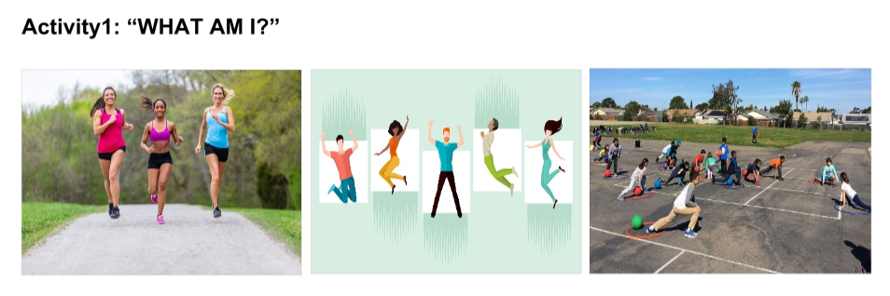

**Social Outdoor Traning**

**ACTIVITY 2: JUMBLED LETTERS**

**Directions**: Unjumble the letters to form a word that corresponds to its meaning.

1. LAXAI NTVEMOME Axial Movement
2. OORTCOMLO EMONTVEM Locomotor Movement
3. DOYB NSDISIOVI Body Divisions
4. REDICONTI FO ENMOVTSEM Direction of Movements
5. MEVENTMO Movement
6. Type movement is done by a part or several parts of the body in a stationary place.
7. Type of movement that brings the performer from one place to another.
8. A major section or segments of the body.
9. Directions of steps can be indicated either in relation to the room or in relation to the body position.
10. The act or an instance of moving; a change in place or position.

**Activity 3: Read, Think and Share**

**Directions**: Read and understand the concepts below. You can raise questions that you want to clarify where students and teacher must collaborate in this part.

Participation in physical exercise requires movement competencies. If movement competences are not established and nourished from a young age, this might lead to inactivity and the associated health and social concerns. The diagram below shows how movement abilities lay the groundwork for involvement in various physical activities.

**Sending** is the process by which a youngster transfers or sends an object away from them. Throwing, kicking, head butting, and other inventive ways may be used. For instance, if the purpose of a game is to strike a target (such as a plastic cone/pylon), the youngster has several possibilities. For example, he or she may throw the ball underhand or (sending upper overhand body) or kick (sending lower body) it toward the target.

**Receiving** abilities include a child's ability to catch or receive an object. This can involve catching, stopping a ball with their foot, trapping an object with their body, or other inventive means.

**Transporting** abilities include many modes of movement such as walking, running, hopping, skipping, and jumping (upright transporting), but also rolling and tumbling (vertical or prone transporting).

**Body control** talents include balance and the ability to move one area of our body while holding the others steady. It may involve stationary body control skills.

**Activity 4: Synthesizing Ideas**

Guide Questions:

1. What is Movement Competency all about?

* Movement Competency refers to how well you utilised your body. This is used to conduct basic movement patterns such as squatting and deadlifting, as well as basic coordination patterns such as crawling and lunging. The ultimate objective is to build a basic baseline level of quality movement rather than amount of movement. There's a reason humans enjoy doing simple actions like crawling, rolling, and getups.Its purpose is to promote movement competency rather than physical capability.

1. Why do you think familiarizing oneself with these movement competencies is important?

* Movement competences are required for involvement in physical activities. If movement competences are not cultivated and nourished from a young age, this might lead to inactivity and the health and social concerns associated with inactivity. The picture below shows how movement abilities lay the groundwork for involvement in various physical activities.

1. How do Send, Receiving, Transporting and Body Control Skills affect one another?

* **Sending** is the process by which a youngster transfers or sends an object away from them. Throwing, kicking, head butting, and other inventive ways may be used. For instance, if the purpose of a game is to strike a target (such as a plastic cone/pylon), the youngster has several possibilities. For example, he or she might toss the ball underhand or overhand (sending upper body) or kick (sending lower body) toward the target.
* **Receiving** **skills** include a child's ability to catch or receive an object. This can involve catching, stopping a ball with their foot, trapping an object with their body, or other inventive means.
* **Transporting** **skills** include many modes of movement such as walking, running, hopping, skipping, and jumping (upright transporting), but also rolling and tumbling (vertical or prone transporting).
* **Body control** **skills** include balance and the ability to move one area of our body while holding the others steady. It can encompass stationary (e.g., standing while putting on shoes or reaching up to obtain an article from a high shelf) or movement body control abilities (e.g. walking while balancing on the curb of a sidewalk)

**Activity 5: "PICK ONE AND DISCUSS"**

**Directions**: Choose one benefit of mobility training from the list below. Discuss it briefly to class.

The benefits of mobility training are plentiful:

* Promotes good posture (looking at you, desk-workers),
* Good posture is essential for general health and provides several advantages such as reduced back discomfort, more energy, and higher confidence. Good posture is essential for general health since it may help you prevent muscular strain, soreness, exhaustion, and a variety of other common disorders and medical issues. It's never too late to fix or improve your posture, especially if it's causing one or more health issues.

**Module No. 6**

**Week 7**

**Activity 1: Complete Me**

**Directions**: Supply the missing letters to complete the words.



* **Movement Competency**

**Activity 2:**

**Directions**: Using the words you have completed in the previous activity,

Give your ideas about this.

1. How are these words associated with movement competency?

* It is spelled Movement Competency and is beneficial to your body Movement competencies are essential for participation in physical activities. If movement competencies are not developed and nurtured from a young age, this may lead to inactivity and the accompanying health and social consequences. The diagram below depicts how movement abilities provide the framework for participation in diverse physical activities.

**Activity 3: Be Informed**

**Directions**: Carefully read the following statements. Pick out a number and explain your answer briefly.

1. A balance of stability and mobility is therefore necessary for the successful completion of all fundamental movement patterns.

* **Muscle imbalances must be addressed using a unique approach to training program creation. However, the correct movement-prep activities at the start of a workout may make a tremendous impact, allowing you to get the most out of your sweating time. Movement preparation is executing fundamental movement patterns in a variety of directions and at varying rates in order to engage the neurological, circulatory, and respiratory systems, which are in charge of directing and fuelling movement. Before tackling the very difficult lifts in a training regimen, a thorough movement-prep warm-up program helps minimize muscle tension, restore joint motion, and achieve optimum mobility.**
* **Your body is intended to move, and effective movement requires many muscles and joints to operate together at the same time. When one area of the body moves, it can affect motion throughout the rest of the body. It is critical to understand that joints in the body do not work with a single fixed axis of rotation. Your body is built in such a way that it is energy efficient. Injuries caused by a decrease of joint mobility can be avoided.**

**Module No. 7**

**Week 8**

**Warm-up** — refers to preparatory exercise performed prior to engaging in more vigorous activities. Warm-up exercises should be dynamic. Dynamic means actively warming up the body moving in a variety of directions at different rates or speeds. This not only activates the tissues but also the nervous, circulatory, and respiratory systems that are responsible for controlling and fueling the body for a tough and physically demanding workout.

A **cool-down** will help in gradually bringing the body back to the resting state through static stretching which also enhances flexibility. It is important to note that dynamic warm-up is not the same as flexibility (e.g., static stretching) Training flexibility involves the bilateral or unilateral action (i.e., contraction, lengthening) of opposing muscle groups to produce joint movements. It is typically assessed in a non-weight-bearing situation.

**Proprioceptive Neuromuscular Facilitation or PNF** is another form Of stretching that combines static stretch and isometric stretching for the purpose of enhancing flexibility. PNF has been proven to enhance active and passive RON.

The functional core assessment as well as the level of core stability that has been achieved can be used to identify whether there are limitations in mobility and flexibility. This assessment can also be used as movement preparation and form part of the warm-up routine.

**The benefits and effects of warm-up include:**

1. Increased heart rate and respiratory rates resulting in better circulation
2. Increase in muscle temperature causing more forceful contractions and quicker relaxation.
3. Increased joint mobility.
4. Increased in mental readiness

**Effects of specific warm-up before a game**

A study conducted by Silva et al (2018)10 to 10 minutes duration of short active warm- up recommends 10 to 10 minutes duration of short active warm-up, and strategy before gradually increasing intensity. After the warm-up it is recommended to warming up the muscles too using heated garments to maintain its temperature.

RUBRICS

|  |  |  |
| --- | --- | --- |
| 4 (100%) | Exemplary | Comprehensive/Analytical Answer |
| 3 (90% ) | Competence | Well expressed/lnclude Core Analysis |
| 2 (80%) | Less than consistent | Lack of Substance/Lacks analysis |
| 1 | Little or no Success | No Substance/No Analysis |

**Activity 1: Pictures analysis**

**Directions**: Determine the different joints and muscles that will be mobilized or involved in the picture.

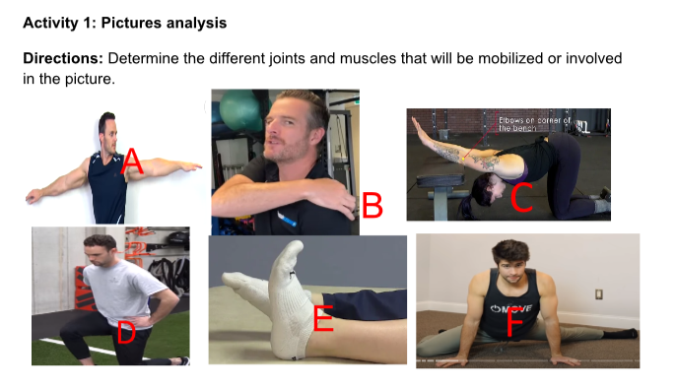

* + - 1. **Shoulder muscles**
      2. **Neck muscles**
      3. **Back muscles**
      4. **Leg muscles**
      5. **Ankle joints**
      6. **Hip muscles**

**Activity 2**

**Directions**: Using the information you got from the previous activity, Give your brief answers to the questions below.

1. How are those pictures associated with exercises?

* It demonstrates how vital it is to reduce stress on the joints and muscles in order to avoid injuries. Although body composition includes muscle, bone, and fat, it is generally represented merely as a proportion of body fat.

1. Do you think those exercises are important for proper mobilization?

* It relieves tension in the joints and muscles while also preventing injuries. Flexibility refers to your joints' ability to move through their complete range of motion without discomfort or stiffness. The pliability of the muscles that support the joints is also referred to. Muscles and tendons that are flexible allow for a broader range of motion during activities.

**Activity 3: Read and Comprehend**

**Directions**: Read the different statements and concepts below. You can raise questions that you want to clarify where students and teachers must collaborate on this point.

**Warm-up** – a preparatory activity conducted before participating in more strenuous activities. Warm-up activities should be active in nature. The term "dynamic" refers to actively warming up the body by moving it in different directions at varying rates or speeds. This activates not just the tissues, but also the neurological, circulatory, and respiratory systems, which are in charge of directing and feeding the body for a strenuous and physically demanding workout.

The capacity of a joint to move freely over its range of motion is referred to as **mobility**.

The combined functioning of the muscles and other connective tissues is referred to as **stability**.

**Warm-ups are classified as follows:**

* **Passive warm-up** entails submerging in a hot tub outside of the body.
* **Warm-up** exercises include brisk walking, mild running, or riding a stationary bike. Warm-ups, both general and particular, are the most popular strategies to boost muscle temperature through low-intensity workouts.

**Activity 4: Guide my Thoughts**

**Directions**: Answer the following questions based on the previous activity.

1. What are the types of warm-up? Differentiate one from the other.

* **PASSIVE WARM-UP** involves external means of immersing in a hot tub

Massages, heating pads, steam baths, and hot showers are examples of such treatments.

* **GENERAL WARM-UP** - Warm-up activities include brisk walking, light jogging, or riding a stationary bike. Warm-ups, both general and specific, are the most popular tactics for increasing muscle temperature during low-intensity activities. Warm up with 5 minutes of mild (low intensity) physical exercise such as walking, running on the spot or on a trampoline, or cycling. Pump your arms or do big yet controlled circular movements with your arms to help warm the muscles in your upper body.

1. Explain the importance of the functional core assessment

* The functional core assessment, as well as the amount of core stability attained, can be utilized to determine whether there are mobility and flexibility limits. This evaluation can also be used to prepare for activity and as part of the warm-up routine. Functional evaluations give evidence to help create, enhance, and attest to various evidence-based therapies. These tools are frequently used in the clinical context to create rehabilitation objectives, devise particular therapy strategies, and track clinical improvements.

1. Enumerate the benefits of warm-up and cool-down exercises.

* Increased cardiac and respiratory rates result in improved circulation.
* Muscle temperature rises, generating more powerful contractions and faster relaxation.
* Joint mobility has been improved.
* Mental preparedness has improved.

1. What other supplementary activities can develop flexibility, mobility, and stability?

* Warm-ups and gentle workouts focus on joints and muscles. Stretching is one of the various activities you may do to enhance your flexibility. Your chosen way of warming up before a workout may be static stretching, or holding one posture for a lengthy amount of time.

**Activity 5:**

**Directions**: Plan and design an exercise routine for the purpose of warm-up that will enhance and improve mobility and stability. Identify the joints involved in the exercises.

|  |  |  |
| --- | --- | --- |
| Exercises | Sets/ Reps | Rest time |
| Shoulder rolls | 20 sets/ 2 reps | 8 mins |
| Leg circles | 20 sets/ 3 reps | 12 mins |
| Ankle rolls | 15 sets/ 2 reps | 8 mins |
| Arm swings | 20 sets/ 3 reps | 10 mins |
| Knee-to-chest | 15 sets/ 2 reps | 15 mins |
| Arm circles | 15 sets/ 3 reps | 10 mins |
| Walking lunges | 10 sets/ 3 reps | 12 mins |
| Torso twists | 15 sets/ 2 reps | 10 mins |

**Module No. 8**

**Week 10**

**TOPIC OR LESSON: Cardiorespiratory Fitness & Locomotor Skills**

**SUB-TOPIC/S : Locomotor Skills, Crawling /Running /Jumping**

**OVERVIEW OF THE TOPIC**

**Cardiorespiratory fitness (CRF)** refers to **the capacity Of the circulatory and respiratory systems to supply oxygen to skeletal muscle mitochondria for energy production needed during physical activity.**

Locomotor skills involve transporting the body or traveling from one point to another with the goal of maintaining dynamic stability while the body is displaced. Skills progress through stages of development. Basic acquisition of the fundamental techniques. proficiency in fundamental skills leads to greater readiness and confidence to explore new activities and learn more skills, as well as participate in a wide range of activities. When this happens, there are more opportunities to have fun, become fit, and even excel in sports. Locomotor Skills enable everyone to move through different environments moving their bodies from one location to another, helping them build confidence and develop a sense of freedom. Having the proper amount of physical activity is thus important for gaining the maximum benefits and mitigating risks while having mature locomotor pattems is crucial to building lifelong physical activity habits

**ACTIVITY 2: KNOWLEDGE FORMATION IDISCUSSION**

**DICRECTION**: Describe what you need to know and how important it is to an individual.

**Locomotor Skills**

**Crawling Exercises**

The crawling pattern impacts our neuromotor abilities, core stability, and mobility. Crawling requires synchronous or contralateral movement of the limbs on both sides of the body. This demands that information pass through the corpus callosum (a broad band of the nerve), which links both hemispheres of the brain, hence, establishing new neural connections and strengthening them. This appears to improve coordination and learning.

During contralateral movements, the core is responsible for transferring energy across the midline. A pronounced "wagging" of the hips while crawling is an indication of poor core stability.

Getting into a quadruped position and rocking the hips back toward the heels functions to help mobility of the lumbo—pelvic complex.

**Sample crawling Exercises**

|  |  |  |
| --- | --- | --- |
|  | Standard | Progression |
| Linear Movement | Baby Crawl | Linear bear crawl |
| Linear crab crawl |
| Gorilla crawl |
| Plank crawl |
| Lateral Movement | Circular Crawl | Lateral bear crawl |
| Lateral crab crawl |
| Sideways Gorilla crawl |
| Lateral side walk |

**BABY CRAWL**

Starting Position - In a quadruped position, align the knees under the hips and the wrists under the shoulders.

**Procedure:**

1. Move contralaterally by stepping forward with one hand and the opposite knee.
2. Repeat with the other hand and knee.
3. Keep the steps small so that the opposite arm and leg can work together.
4. Crawl backwardly by performing the same contralateral movement pattern.

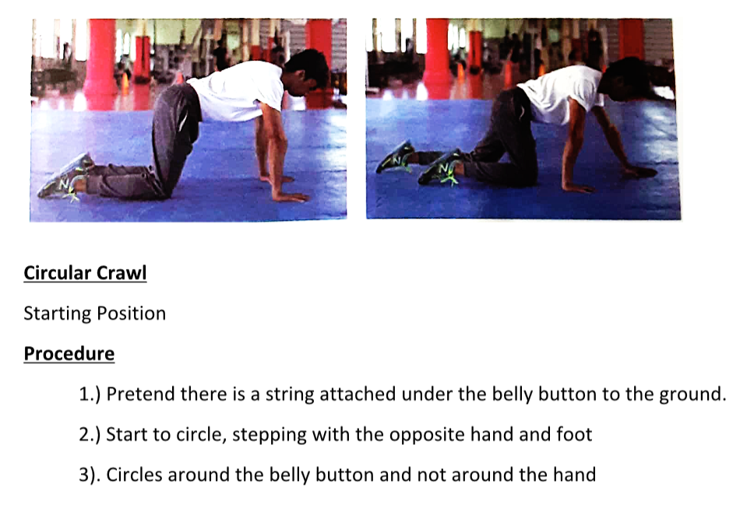

**Circular Crawl**

Starting Position

**Procedure**

* 1. Pretend there is a string attached under the belly button to the ground.
  2. Start to circle, stepping with the opposite hand and foot
  3. Circles around the belly button and not around the hand

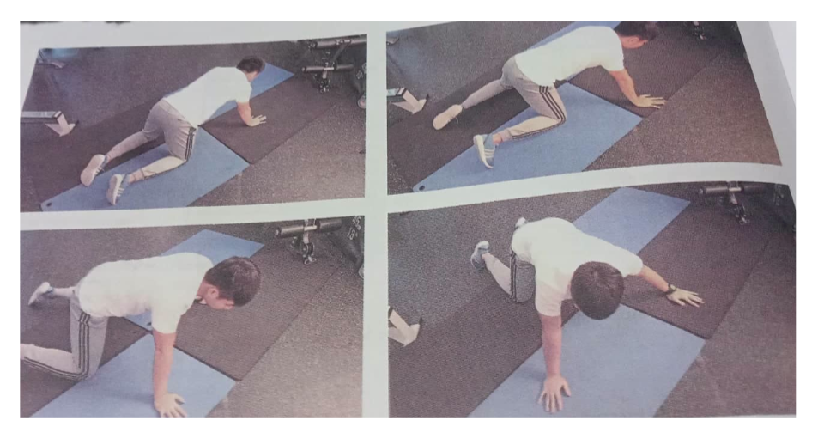

**Take Note**

* 1. Take small steps at a time.
  2. Neck in meutral position
  3. Core is engaged throughout the movement

**Exercise Progression**

**Linear Crawl**

Starting Position: Same as the baby crawl but slightly lift the knees about two inches off the ground.

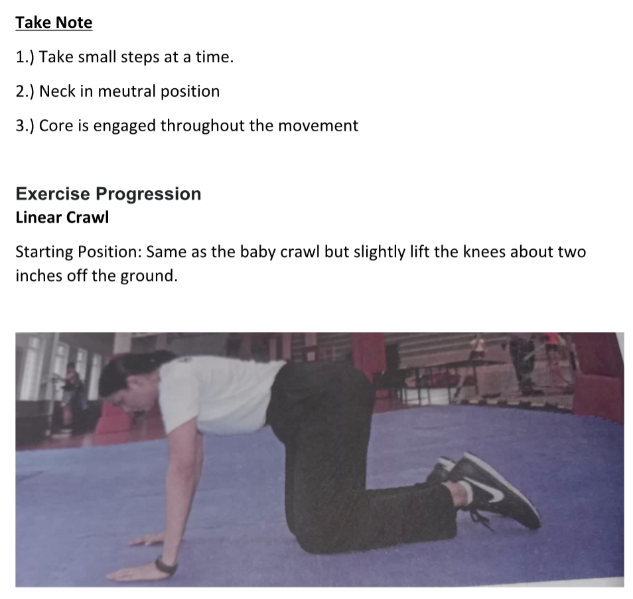

**Procedure**

* 1. Move contralaterally by walking forward with one foot and opposite hand.
  2. Keep crawling forward, moving the opposite arm and opposite leg together.
  3. Crawl backward by keeping the same movement pattern.

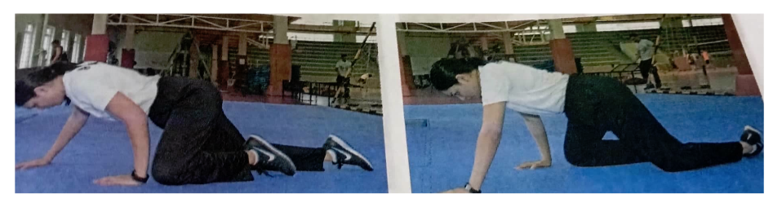

**Lateral bear crawl**

Starting Position: Same as the linear bear crawl.

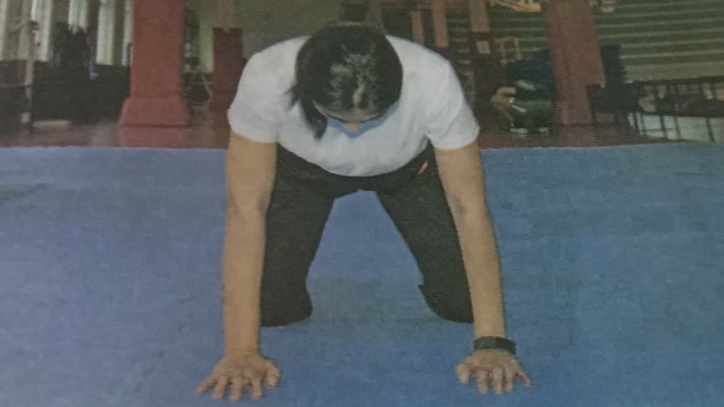

**Procedure:**

1. Move sideways to your left by walking left hand and right knee simultaneously to right a few inches.
2. Follow with the right hand and left knee moving in the same direction.
3. Continue crawling over a distance.
4. Reverse the pattern by moving to your right, walking with the right hand and left knee simultaneously.
5. Follow with the left hand and right knee.
6. Continue crawling over a set distance.

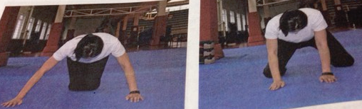

**Take Note:**

1. Take small steps to keep the hip stable and to keep up with the contralateral movement.
2. Keep the knees as close as to the floor.
3. Do not allow the hips to rise up.
4. Keep the lower back from rounding.
5. Maintain the brace.

**Linear Crab Crawl**

Starting Position

1. Sit on the floor with knees bent and flat.
2. Place the hands on the floor behind the glutes and slightly lift the glutes ( a large muscle of the buttocks).

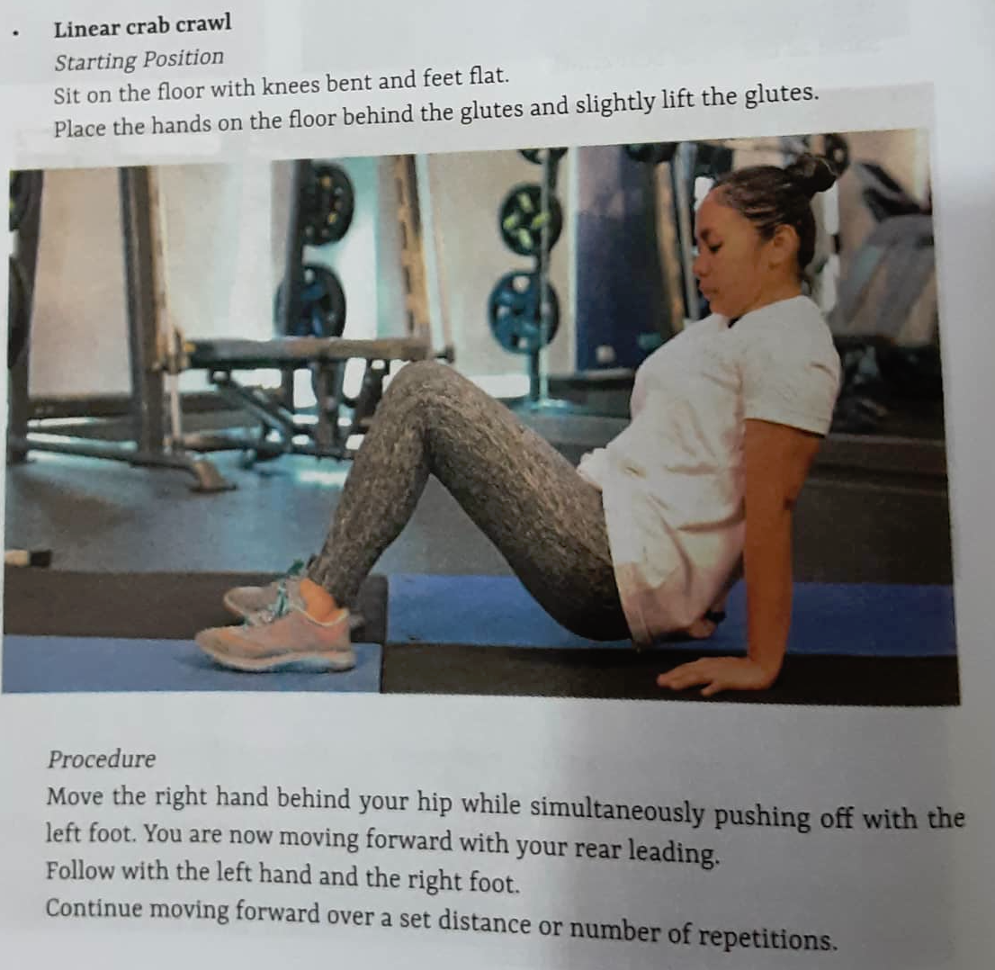

**Procedure:**

1.) Move the right hand behind your hip while simultaneously pushing off with the left foot. You are now moving your rear leading.

2.) Follow with the left hand and the right foot.

3.) Continues moving forward over a set distance or number of repetitions.

As a progression reverse the pattern crawling back with the feet leading instead of the rear.

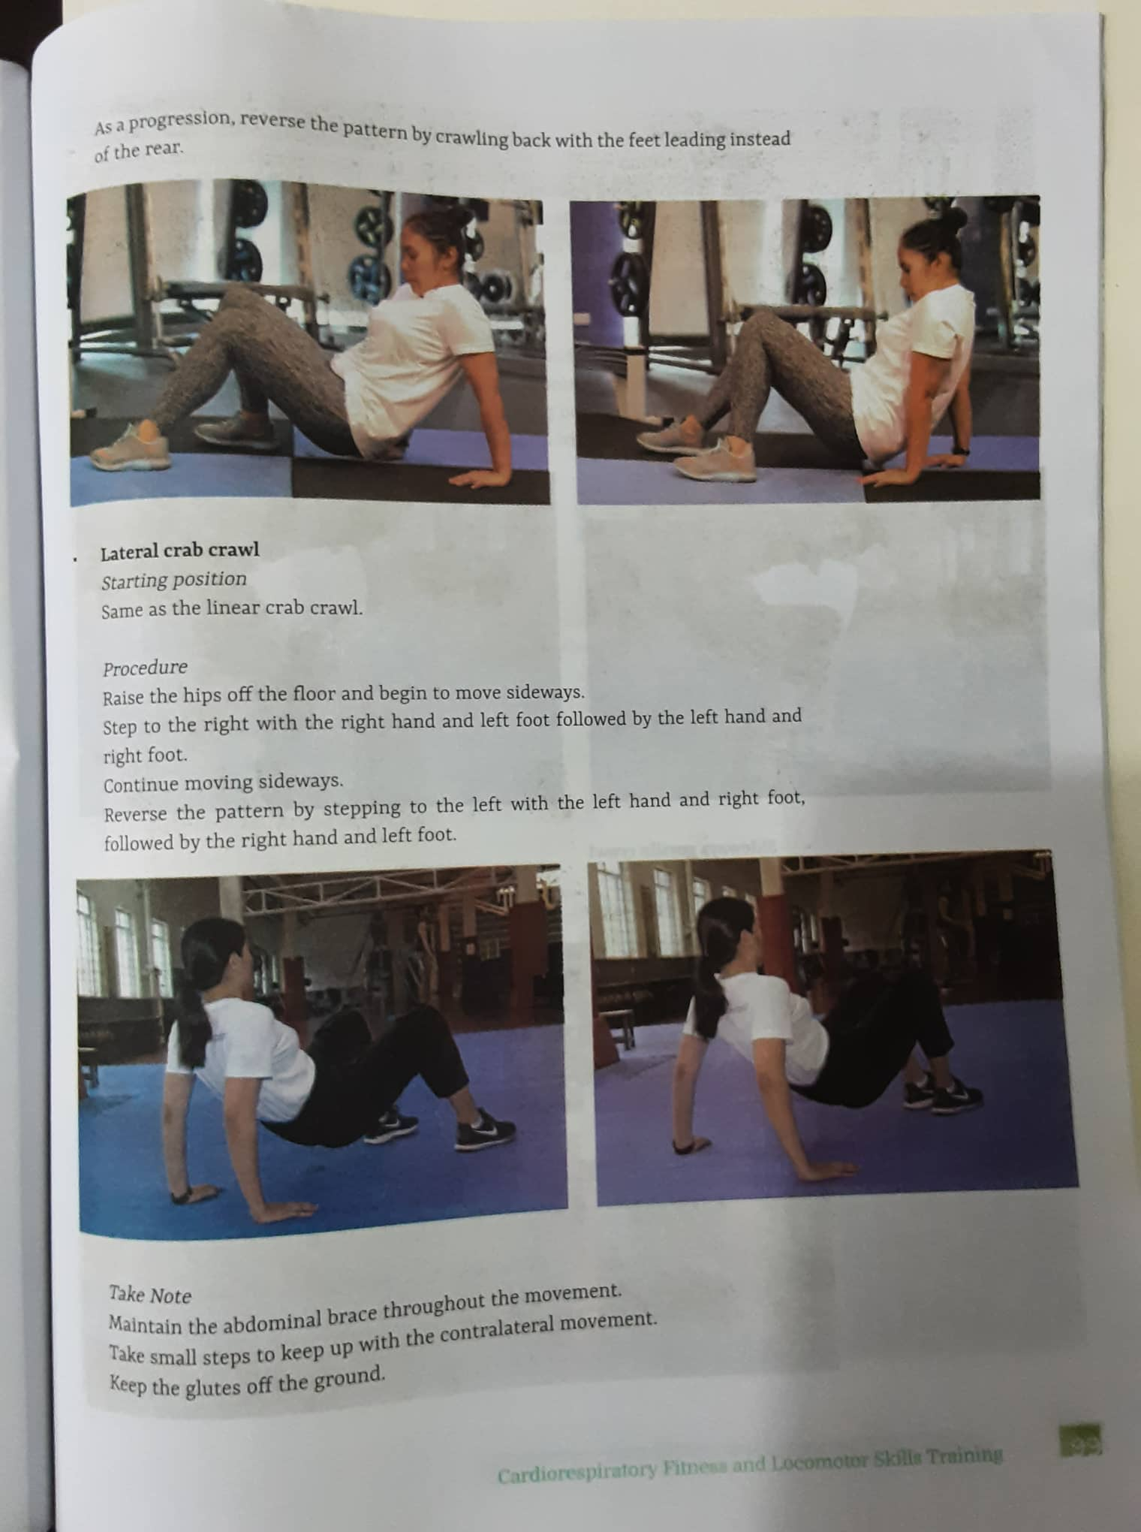

**Lateral Crab Crawl**

Starting Position: Same as the Linear Crab Crawl

**Procedure:**

1. Keep the hips off the floor and begin to move sideways.
2. Step to the right with the right hand and left foot followed by the left hand and right foot.
3. Continue moving sideways.
4. Reverse the pattern by stepping to the left with the left hand and right foot followed by the right hand and left foot.



**Take Note:**

1. Maintain the abdominal brace throughout the movement.
2. Take small steps to keep up with the contralateral movement.
3. Keep the glutes off the ground.

**Gorilla Crawl**

Starting Position:

1. Start in a crouching position.
2. Position the feet shoulder-width apart.
3. Place the weight on the balls of the feet.
4. End over and place the hands on the floor.

**Procedure:**

1. Shift the weight of the body to the hands as you jump forward.
2. Land with the feet positioned outside the hands.
3. Reach forward again and place the hands on the floor before jumping.
4. Continue moving forward over a set distance or a prescribed number of repetitions.

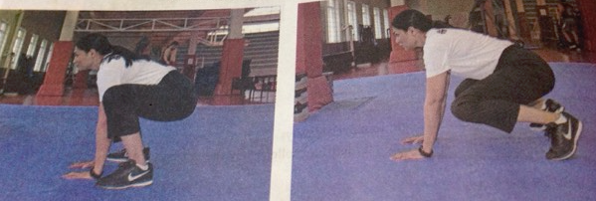

**Sideways Gorilla Crawl**

Starting Position: same as the gorilla crawl

**Procedure:**

1. Lift the hands and reach out to the left
2. Place the hands o the floor and jump with the feet past the hands to the left.
3. Continue moving in the same direction.
4. Reverse the direction but continue to perform the same movement pattern.

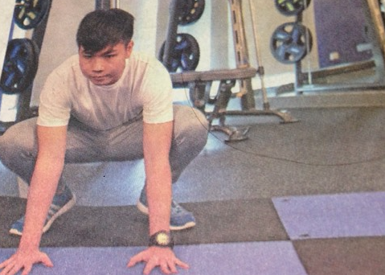

**Procedure:**

1. Lift the hands and reach out to the left
2. Place the hands o the floor and jump with the feet past the hands to the left.
3. Continue moving in the same direction.
4. Reverse the direction but continue to perform the same movement pattern.

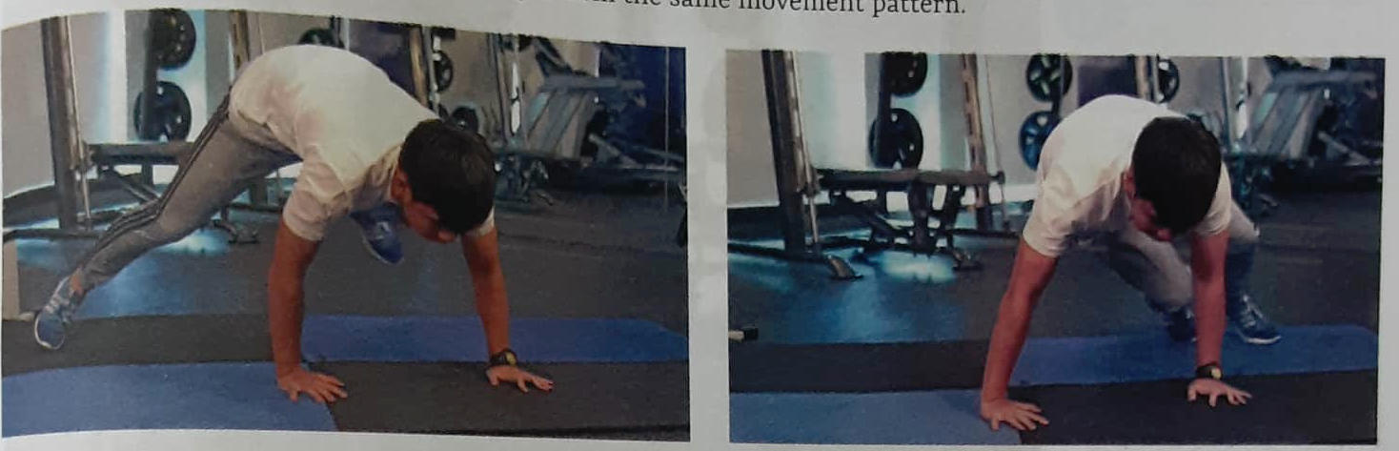

**Take Note**

Stay low in a crouching position throughout the entire movement.

Reach out with your hands as soon as the feet land on the floor.

**Plank Walk**

Starting Position:

* 1. Start on a straight arm plank position.
  2. Keep the wrist under the shoulder.
  3. Extend the legs and keep the feet close together.

**Procedure:**

1. Take a small step forward with a right hand and left foot followed with the left hand and right leg.
2. Continue moving in the same direction.
3. Keep the steps small.
4. Maintain the plank by keeping the body in a straight line and the knee straight.
5. Reverse the direction.

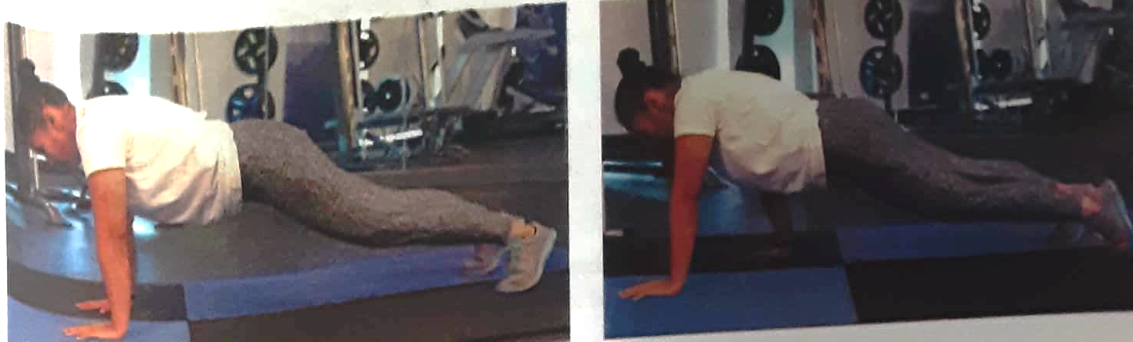

**Lateral side walk**

Starting Position: same as the plank walk

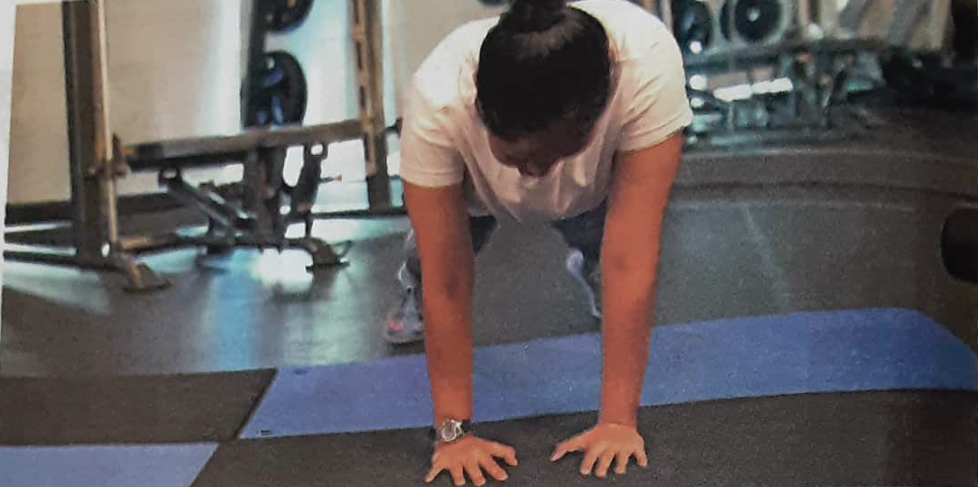

**Procedure**

1. Move the right hand close to the left hand at the left foot step out so the feet are about hipwidth apart.
2. Then move the left hand out so that the hands are about shoulder width apart as the right foot steps in.
3. Keep moving in one direction bringing the feet together as the hands step out wide and the feet out wide as the hands are back together.
4. Reverse the crawl by moving in the opposite direction.

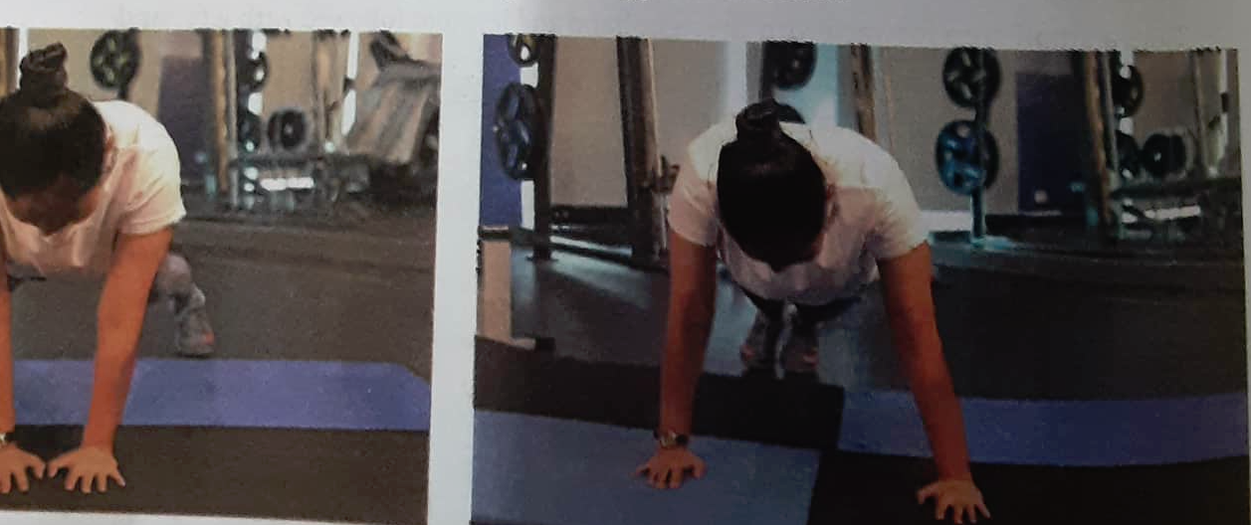

**Take Note**: keep the body in a straight line front from the head to the heels. Take small steps at a time to keep the core tight and to lessen the movement on the hip. Neither let he hip sag nor rise up.

**Jumping and Landing**

To practice proper mechanics of jumping and landing safely, perform simple box jumps (e.g. forward, reverse) and single-leg lateral bounds wherein the landing is held for three seconds (i.e stick the landing) before bounding to the opposite side and landing on the opposite leg. Before doing drills warm up first and include exercises that activate the glutes. Avoid landing stiff-legged because shock is transmitted to the joints instead, specifically the hip, knee, and ankle.

Start the activation of the glutes exercise routine by performing a hip flexor and psoas stretch to relax the hip flexors and specifically suppress the psoas muscle.

**Hip Flexor and psoas stretch**

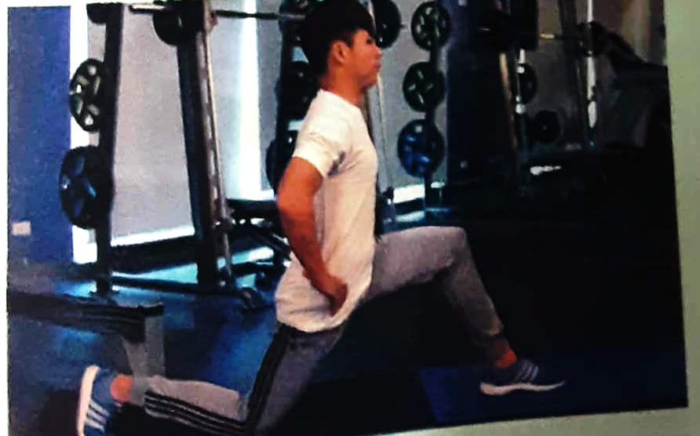

*Jumping (upward motion)*

1. Stand tall and your feet hip-width apart.
2. Flex the elbows 90 degrees and hold the arms in front of the chess.

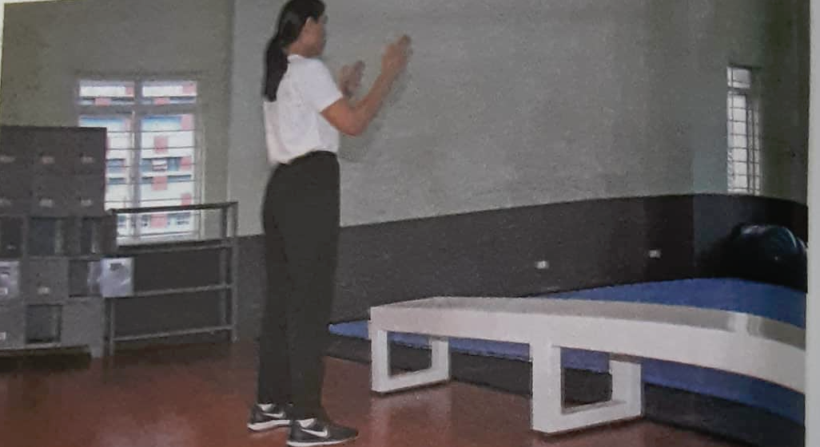

Sit back on your hips (half squat) as you extend the elbows behind. Keep your arms along the side of the trunk.

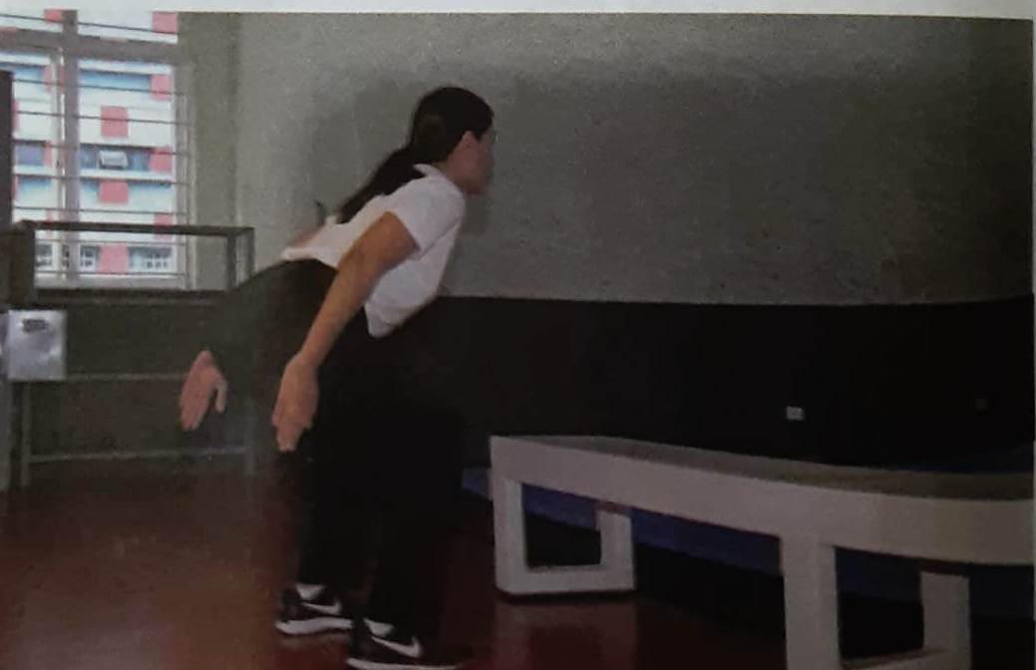

Drive the arms forward to activate the legs into jumping forward landing on the box.

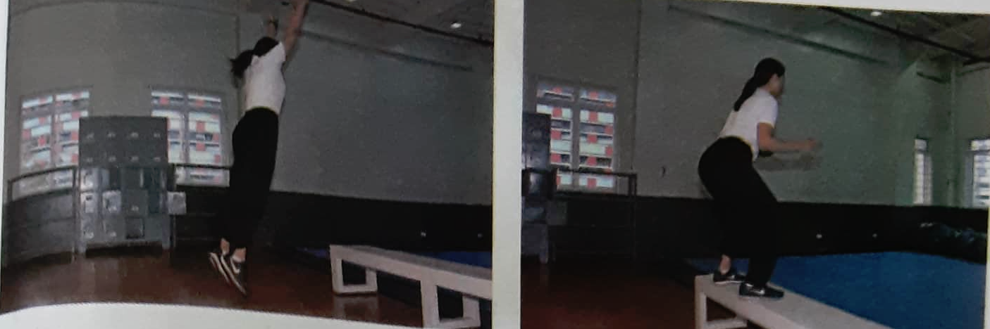

Landing (downward motion)

1. Land softly and decelerate the body by distributing your weight evenly over the entire foot.
2. Keep the spine neutral by looking forward.
3. Keep the knees behind the toes by activating your glutes.
4. Keep the knees or track or aligned with your toes (i.e avoid collapsing the knee inward or medially.
5. Keep the elbows flexed at 90 degrees and hands above them.

**High Knee March Walk**

Starting Position: stand tall, keep the chest up and look straight ahead.

**Procedure**

1. Drive one knee above the hip as you swing the arms with elbows bent at a 90-degree angle.
2. Keep the heel close to the glutes and dorsiflexed.
3. Keep the toes up or plantar flex the support foot during the knee drive.
4. March slowly and avoid slamming the foot onto the ground.

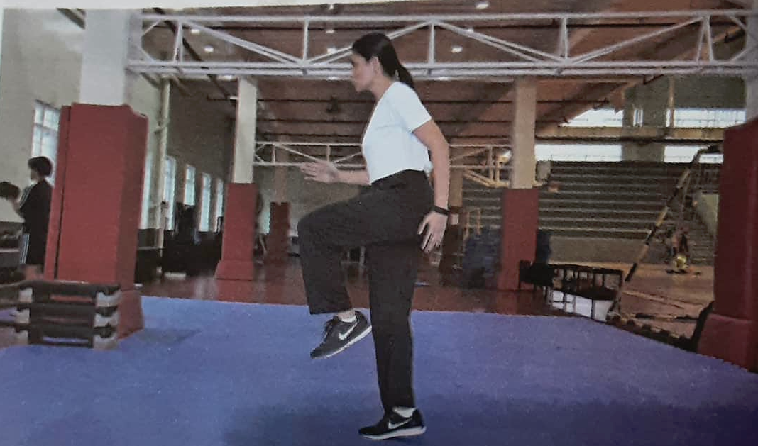

**Exercise Progression**

High Knees

Starting Position: Stand Tall

**Procedure**

1. Drive the knees high with the hip and quickly bring it back on the ground.
2. Perform this with alternating leg.
3. Concentrate the body weight on the ball of the foot.
4. Swing the arms while keeping the elbows bent 90 degrees.
5. Continue moving forward as possible until the desired distance is covered.
6. Focus on technique first before increasing the tempo of the movement.

**Exercise Variation**

**Lateral High Knees**

Follow the execution of high knees but move sideways.

Perform on one side first until a desired distance is covered and repeat on other side.

**A-Skips**

Starting Position

Stand tall

Keep the chest up and look straight ahead.

**Procedure:**

1. Skip forward by pushing from one foot and driving the other knee up high above the hip.
2. Swing the arms forcefully while the elbows are bent in a 90-degree angle.
3. Continue to skip forward while performing on one side first ( i.e ) with the same knee driven higher repetitively.
4. Progress by skipping forward at alternating knees or legs.

**Take Note**

1). Push off quick and fast

2.) Avoid jumping too high.

3.) Focus on technique first before increasing the tempo of the movement.

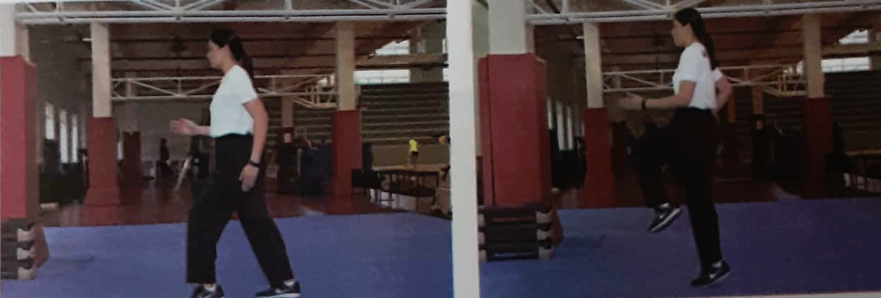

**Exercise Progression**

A- Skips with alternating knee

**Exercise Variation**

**Lateral A-Skips**

1. Follow the execution of A- skips but move sideways.
2. Perform on one side first until the desired distance is covered.
3. Repeat on the other side.

**Procedure:**

1. Push off with one foot and step sideways with the other foot.
2. Lift the push-off foot and go back to the starting position.
3. Keep the weight centered on the body.
4. Keep the heel off the ground or stay on the balls of the feet.
5. Maintain the heel at the same level (avoid bobbing up and down).
6. Continue to move sideways until the desired distance is covered.
7. Change direction and repeat on the other side

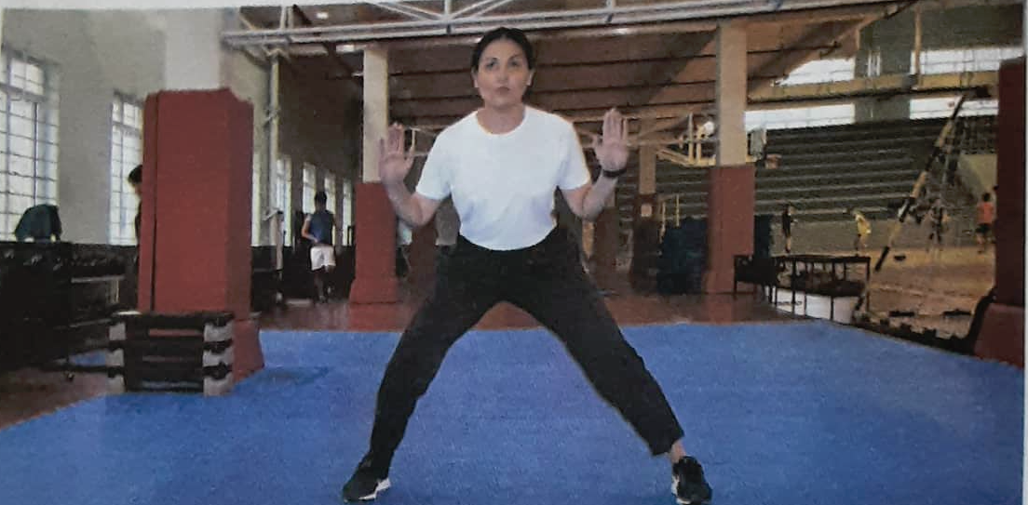

**CARIOCA**

Starting Position: Start with the knees slightly bent and feet wider than the hip.

**Procedure:**

1. Moving to the right, lift the left foot up and cross it in front of the right foot.
2. Then move the right foot to the side to go back to the starting position.
3. Cross the left foot behind the right foot and move the right foot to the side.
4. Continue moving to the right, crossing the left foot forward than behind until the desired distance is covered.
5. Repeat on the other side.

**Take Note**

1. Raise the arms to the side at shoulder height to keep the balance.
2. Keep the shoulder square.
3. Twist the hip every time the leg crosses.
4. Move on the balls of the feet.

**Exercise Variation**

**High Knee Carioca**

Follow the execution of carioca.

Powerfully drive the knee up almost in line with the hip as it crosses over the front leg.

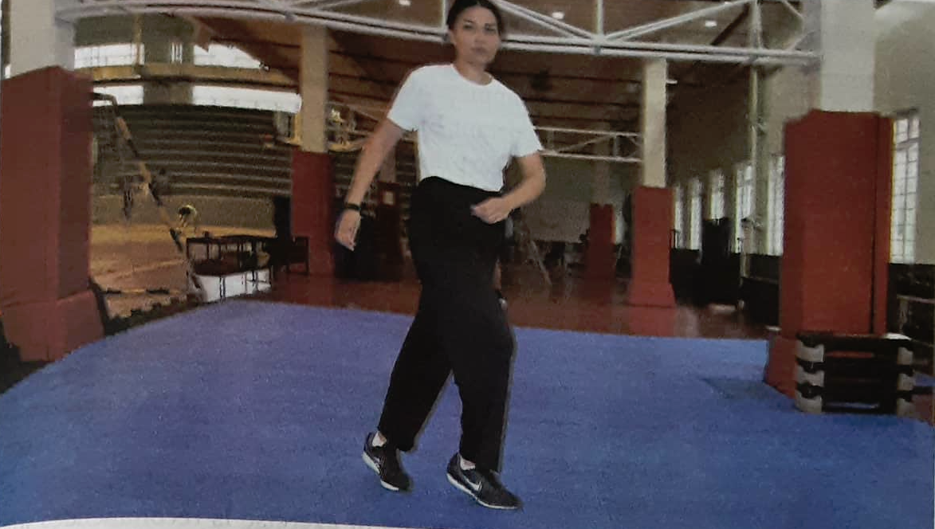

**Activity 1: PICTURE ME**

**Directions**: The following words are so important to our cognition of the topic, Unjumbled the letters to form a skill based on the picture below.

1. pinghop **hopping**
2. Lingcraw **crawling**
3. chingmar **marching**
4. bingclim **climbing**
5. lopingal **polling**
6. dingsli **sliding**
7. pinglea **leaping**
8. nningru **running**
9. kingwal **walking**
10. pingjump **jumping**
11. bicsaero **aerobics**
12. clingcy **cycling**
13. mingswim **swimming**
14. xingbo **boxing**
15. kingplan **planking**

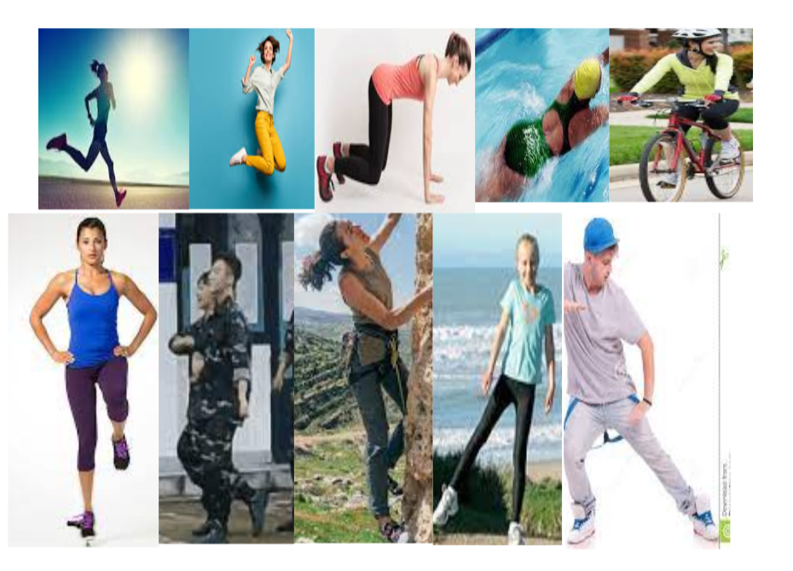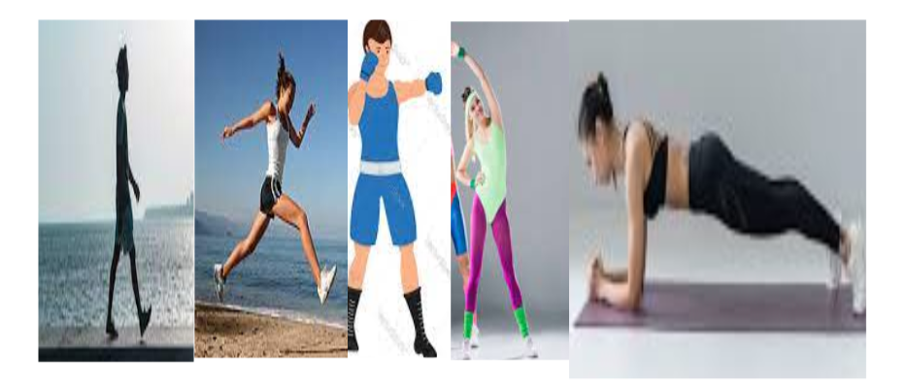

**Aerobics**

**Boxing**

**Jumping**

**Climbing**

**Marching**

**Sliding**

**polling**

**Planking**

**Swimming**

**Cycling**

**Walking**

**Running**

**Leaping**

**Crawling**

**Hopping**

**ACTIVITY 2 Spot the Term /Test your Knowledge**

**DIRECTION:** Derive the answer from the enumerated important terms .

**Locomotor skills Cardiorespiratory fitness or CRF**

**Aerobic activities Running Jumping**

**Skipping Motion Leaping**

**Crawl Mitochondria**

**Mitochondria** 1. Are membrane-bound cells that generates most of the chemical energy needed to power the cell’s biochemical reaction.

**Locomotor skills** 2. Involve transporting the body or traveling from one point to another with the goal of maintaining dynamic stability.

**Motion** 3. Is defined as an individual’s change in space over a time period. Movement can either be forward or backward.

**Skipping** 4. Consists of a forward step followed by a hop on the same foot. There is alternation of the lead leg with an uneven rhythmic pattern.

**Jumping** 5. Occurs when the body is projected into the air by force generated in one or both legs and the body lands on one or both feet.

**Aerobic activities** 6. These are physical activities that require repetitive and sustained movements of large muscle groups over a period of time.

**Leaping** 7. Jump and spring a long way.

**Crawl** 8. Move forward on the hand and knees or by dragging the body closer to the ground.

**Cardiorespiratory fitness or CRF** 9. Refers to the integrated function of the cardiovascular and respiratory system to ensure a continuous supply of oxygen and nutrients as well as the elimination of waste products or substances.

**Running** 10. Occurs when (1) legs alternate to propel the body through the air or the support phase, (2) both feet are lifted off the ground or the flight phase, and (3) a foot strikes the ground upon landing or the recovery phase.

**Activity 3: Ponder and Pass On**

**Directions: Convey and acknowledge the recommended Exercise for cardiorespiratory ( CRF). Active participation in the exchange of purpose is expected.**

The American College of Sports Medicine(ASCM) in their position stand published in 2011 has made evidence-based recommendations on how to develop and maintain cardiorespiratory fitness. This is important because an increase in cardiorespiratory fitness decreases the risk for chronic heart disease, stroke, diabetes, and some form of cancer. Another benefit is that it decreases mortalitty and morbidity. Engaging in physical activity and exercise regularly also improves blood pressure, cholesterol profile, insulin sensitivity, and helps control weight.

Based on the review of available research and data, the ASCM recommends the following:

1. **Frequency**: It is a recommended exercise on most days of the week. To be more specific, five days per week or more for moderate exercise or three days per week for vigorous exercise, or three to five days of combinations of some days of moderate exercise and some days of vigorous exercise.
2. **Intensity:** Moderate to vigorous intensity of exercise is recommended while light to moderate intensity is recommended for deconditioned individuals (elderly, or those who have illnesses making them inactive. Sendentary persons who spend most of their time sitting, like watching TV, or using computer, are still recommended to do moderate intensity exercise.
3. **Volume:** Daily moderate-intensity exercise lasting for 30 to 60 minutes ( or 150 -300 minutes per week) is recommended. For vigorous-intensity exercise this would be 20 to 60 minutes per day or a total of 75 minutes per week. It is important to note that the recommended minutes are for the days the peson will be exercicsing. For sedentary people, working your way into the recommended intensity is ideal. A volume of fewer than 20 minutes per day may still be beneficial.
4. **Type:** The activity done should be regular, a purposeful exercise that involves the major muscle groups. The execise should also be continuous and rhythmic in nature. This means that the exercise should be designed with fitness development in mind.
5. **Pattern:** Exercise may be performed in one session per day or in small sesions of 10 minutes to accumulate the desired duration of exercise for the day. According to the ASCM, evidence for this has been gathered from a rich body of data.
6. **Progression:** Exercise progression should be done gradually by modifying the duration, frequency, and/or intensity until the exercise goal is achieved( in this case, cardiorespiratory fitness). It is important to always keep in mind that the intensity should always be challenging enough yet not too much that it will cause injury.

When increasing the pedometer count from 2000 to a daily step count of 7000 steps maintain a pace of 100 steps per minute (while also keeping the recommended length of exercise duration) to stimulate improvement in cardiorespiratory fitness level.

**Activity 4: Integrating Purposes**

**Recognize if the following are True or False**

1. Skills progress through stages of development.

**True**

1. Proficiency in the fundamental skills leads to greater readiness and confidence to explore new activities and learn new skills, as well as participate in a wide range of activities.

**True**

1. When this happens, there are more opportunities to have fun, become fit, and even excel in sports.

**True**

1. In contrast not having enough skills means playing less and choosing not to participate in physical activities.

**False**

1. Mastery of the fundamental skills is the key to developing and maintaining lifelong physical activity habits.

**True**

**ACTIVITY 5: Stage My Moves**

**DIRECTIONS:** Formulate a 5 minute personal cardiorespiratory exercise (Interval 20/10.

|  |  |  |
| --- | --- | --- |
| Exercises | Sets/ Reps | Rest time |
| Cycling | 20 km/ 1 rep | 20 mins |
| Planking | 2 mins/ 2 reps | 8 mins |
| Running | 10 km/ 2 reps | 8 mins |
| Walking | 5 km/ 2 reps | 10 mins |
| Swimming | 2 laps/ 2 reps | 30 mins |
| Jumping | 25 sets/ 3 reps | 8 mins |
| Boxing | 30 mins/ 2 reps | 15 mins |
| Marching | 10 km/ 2 reps | 10 mins |

**Module No. 9**

**Week 11**

**Locomotor Skills**

Locomotor skills enable children to move through different environments, moving their bodies from one place to another. The key locomotor skills are WALKING, RUNNING, JUMPING, HOPPING, CRAWLING, marching, climbing, galloping, sliding, leaping, hopping, and skipping.

**How do locomotor movements help develop physical fitness?**

Increasing stability, and building strong muscles, heart, and bones. Development of their locomotor skills such as walking, running, hopping, and climbing. Enhancing their thinking and problem-solving skills. The emergence of manipulative skills - fine motor skills, like squeezing, grasping, pinching, etc.

**What is Cardiorespiratory endurance?**

Cardiorespiratory endurance is the ability of the lungs, heart, and blood vessels to deliver adequate amounts of oxygen to the cells to meet the demands of prolonged physical activity. It is the single most important component of health-related physical fitness. Aerobic exercise is important in pre

**What are the benefits of increasing cardiorespiratory fitness through exercise?**

Increasing cardiorespiratory endurance has a positive effect on your overall health. Your lungs and heart are able to better use oxygen. This allows you to exercise for longer periods without getting tired. Most people can increase their cardiorespiratory endurance by doing regular exercise.

High levels of physical activity and cardiorespiratory fitness are associated with **lower all-cause and cardiovascular mortality**. Furthermore, physical activity can reduce the development of chronic diseases such as hypertension, diabetes, stroke, and cancer.

**Sample CRF exercises:**

|  |  |  |
| --- | --- | --- |
| Duration | Exercises | Resistance Exercise |
| 20-30 minutes | Jogging/Walking | Every day |
| 20-30 minutes | Jumping Jack | 15–20 repetitions; 1–3 sets |
| 20-30 minutes | Cycling | 2–3 sessions weekly (non-consecutive days) |
| 20-30 minutes | Stair climbing | 10–15 repetitions; 1–3 sets |
| 20-30 minutes | Aerobic dance | 2–3 sessions weekly (non-consecutive days) |

**Activity1: “PICTURE paint a thousand WORDS”**

**Directions:** Cross out the words that show non-locomotor skills.

|  |  |  |  |  |
| --- | --- | --- | --- | --- |
| ~~jumping~~ | ~~Bending~~ | ~~hopping~~ | ~~leaping~~ | gliding |
| running | galloping | skipping | rolling | ~~Hip twisting~~ |
| ~~stretching~~ | ~~Pushing~~ | ~~Arm swing~~ | ~~pulling~~ | ~~standing~~ |
| walking | Sliding | ~~Arm curling~~ | ~~static balancing~~ | ~~squatting~~ |

**Activity 2: “Now It Makes Sense”**

**Directions:** Using the above information you got from the previous activity and your previous knowledge about locomotor and non-locomotor skills try to connect them all to make sense of the difference between those skills.

**Non-locomotor Skills**

* Non-locomotor skills include the ability to bend, twist, curl, and sway while using a variety of bodily joints. Stretching, bending, twisting, and hand clapping are non-locomotor abilities. They include any movement of the body that does not involve moving from one location to another. Other instances include turning, tapping the foot, and winking.

**Locomotor Skills**

* The ability to move one's body in a single direction or several different directions from one place to another is known as locomotor movement. Fundamental locomotor actions include walking, jogging, moving forward, backward, sideways, skipping, running, jumping, hopping, and leaping.

**Activity 3: Read, Think and Share**

**Directions**: Read and understand the concepts below. You can raise questions that you want to clarify where students and teachers must collaborate in this part.

**Locomotor Skills**

Children that have good locomotor abilities can move their bodies around in a variety of contexts. The main locomotor abilities include hopping, running, crawling, marching, galloping, sliding, leaping, and skipping.

**How can locomotor activities promote physical fitness?**

Increasing stability and developing strong bones, muscles, and hearts. growth of their locomotor abilities, including as hopping, running, and climbing. improving their capacity for analysis and problem-solving. the development of manipulative abilities, or fine motor skills like pinching, gripping, and squeezing.

**How do you define cardiorespiratory endurance?**

The capacity of the heart, lungs, and blood vessels to provide enough oxygen to the cells to fulfill the demands of sustained physical exercise is known as cardiorespiratory endurance. It is the single most crucial element of physical fitness for health. Aerobic activity is crucial for pre

**What advantages come with improving cardiorespiratory fitness through physical activity?**

Your entire health will benefit from improving your cardiorespiratory endurance. Your heart and lungs can utilize oxygen more effectively. You may workout longer without feeling fatigued thanks to this. The majority of people may improve their cardiorespiratory endurance by exercising often.

Lower all-cause and cardiovascular mortality is correlated with high levels of physical activity and cardiorespiratory fitness. Additionally, regular exercise helps slow the onset of chronic conditions including cancer, diabetes, stroke, and hypertension.

**Activity 5: Synthesizing Ideas**

Guide Questions:

1. Define Cardiorespiratory Fitness?

Cardiorespiratory endurance refers to the ability of the heart, lungs, and blood vessels to give adequate oxygen to the cells to meet the demands of persistent physical exertion. It is the most important aspect of physical fitness for health. Aerobic exercise is essential for prenatal health.

2. What is the relationship between CRF and Locomotor skills? Elaborate on your answer.

**Cardiorespiratory fitness (CRF)** refers to the capacity of the circulatory and respiratory systems to supply oxygen to skeletal muscle mitochondria for energy production needed during physical activity.

**Locomotor movement** refers to the capacity to move one's body in a single direction or numerous diverse directions from one location to another. Walking, jogging, moving forward, backward, sideways, skipping, running, jumping, hopping, and leaping are all basic locomotor motions.

3. Enumerate the benefits of CRF in our health.

Cardiorespiratory fitness improves lung and heart health while also increasing emotions of well-being. Furthermore, there is emerging evidence that CRF may be a better predictor of death than other well-established risk factors including smoking, hypertension, high cholesterol, and type 2 diabetes.

**Activity 3: “Match me”**

**Directions**: Match the following exercises and the part of the body being developed.

Column A Column B

1. Abdominal Curl a. chest and arm

2. Push Up b. abdomen, glutes, and legs

3. Jumping jacks c. calves, quadriceps, and shoulders

4. Plank d. abdomen

5. Squats e. glutes, back and arms

**Answer:**

* + - 1. D
      2. A
      3. C
      4. B
      5. E

**Module No. 10**

**Week 12**

**What Is Resistance Training?**

Resistance training is a form of exercise intended to increase muscular strength and endurance. It involves exercising muscles using some form of resistance. This resistance could be weights, bands, or even your own body weight working against gravity.

When doing resistance training—which is sometimes called strength training or weight training—you can focus on specific results, such as joint stability, muscular endurance, increased muscle size, strength, and power.

**Benefits of Resistance Training**

Resistance training is intended to increase muscular strength and endurance, but it has a wide variety of health benefits, too.

*Here are a few benefits you may experience from incorporating resistance training into your workout routine*.

Boost Metabolism and Reduce Body Fat

Increase Bone Density and Improve Balance

Improve Mental Health

Build Muscle Mass

Improve Muscle Strength and Endurance

Reduce the Risk of Sports Injuries

Increase Self-Esteem

**How to Get Started With Resistance Training?**

According to the CDC, you should try to incorporate resistance training into your workouts on a consistent basis. Because you can use your body weight to begin or even a simple set of dumbbells, you do not have to join a gym or hire a personal trainer to get started. But you do need to make sure you are using proper form in your workouts. Proper form can not only ensure you are getting the most from your workout, but also can decrease your risk of injury.2

***Note:***

If you have a medical condition or a disability—or if you are just getting starting with an exercise routine—you should talk to a healthcare provider for advice. They can provide insight into what is best for you given your medical history.

It is also important to note that you do not have to buy equipment to get started with resistance training. You can use your body weight to do exercises like pushups, squats, planks, and more. Or, you can use household items to add more weight like gallon jugs of water, soup cans in a canvas bag, or a backpack with an unopened bag of flour.

**Equipment for Resistance Training**

Although the equipment is not required when getting started with resistance training, here are some examples of equipment you can purchase for resistance training:

Barbells

Dumbbells

Kettle bells

Resistance bands

Suspension trainers

Pull-up bars

**Activity1: “Meet**

**Directions:** Using the word bank below label the parts of the muscles.

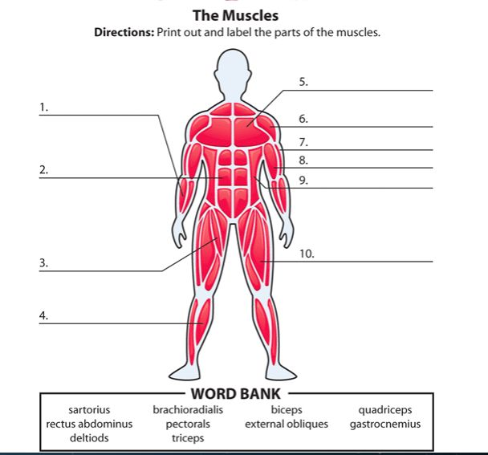

* + - 1. Brachioradialis
      2. Rectus abdominus
      3. Sartorius
      4. Gastrocnemius
      5. Pectrals
      6. Deltoids
      7. Triceps
      8. Biceps
      9. External obliques
      10. Quadriceps

**Activity 2: “The Muscular System”**

**Directions:** Using the above information you got from the previous activity and your previous knowledge about the Muscular system give the function/s of each part and provide a specific task or activity when we usually use it.

It's also crucial to remember that you may begin a resistance training program without purchasing any special equipment. Pushups, squats, planks, and other workouts may all be performed with only your body weight. Alternatively, you may use everyday objects like gallon water jugs, soup cans in a canvas bag, or a backpack with an unopened bag of flour to add extra weight.

**Activity 3: Read, Think and Share**

**Directions**: Read and understand the concepts below. You can raise questions that you want to clarify where students and teachers must collaborate in this part.

A type of exercise called resistance training is used to build muscle strength and stamina. It includes working out muscles against resistance. Weights, bands, or even your own body weight pushing against gravity can be used as resistance.

You can concentrate on certain outcomes when performing resistance training, also known as strength training or weight training, such as joint stability, muscular endurance, increased muscle growth, strength, and power.

**Activity 4: Synthesizing Ideas**

Guide Questions:

1. How important is resistance training to health?

* It is also worth noting that you do not need to purchase any equipment to begin resistance training. You may utilize your body weight to do workouts such as pushups, squats, and planks. You may also use household things like gallon jugs of water, soup cans in a canvas bag, or a backpack with an unopened bag of flour to increase weight.

2. Why is it important to consider the FITT principle when engaging in resistance training?

* The FITT approach supports cross-training in addition to breaking past plateaus. This is when you employ a variety of training methods to achieve your fitness goals. For example, you may alternate between walking, strength training, and dancing to notice benefits and avoid monotony.

3. Can you do resistance training every day why yes? Why not?

* Yes, Working exercise every day is great as long as you're not pushing yourself too hard or becoming obsessed with it. Make it something you love without being too severe on yourself, especially during times of illness or injury.

**Activity 5: “Safety First”**

**Directions**: Explain briefly but precisely why we need to follow and consider the given safety tips in dealing with resistance training.

* + - 1. **Use proper form** – to prevent getting injuries
      2. **Exercise safely** – safety is the top priority
      3. **Bring water** – to avoid dehydration
      4. **Find a workout buddy** - to help you motivate and improve along side with each other
      5. **Stop if you experience pain** - Working out every day is beneficial as long as you don't overdo it or become obsessed with it. Make it something you enjoy without being too hard on yourself, especially if you are unwell or injured.

**Module No. 11**

**Week 13**

Weight management is the process of adopting long-term lifestyle modifications to maintain a healthy body weight on the basis of a person's age, sex, and height. Methods of weight management include eating a healthy diet and increasing physical activity levels.

Managing your lifestyle needs establishing routines especially, in those aspects that elevate health risks. Healthy eating habits anchored with food choice, engagement in physical activities as well as sleeping habits are some of the aspects of your lifestyle that can be transformed for better living.

An unhealthy lifestyle brings with it certain diseases that can shorten your lifespan. All age groups are affected by NCDs, although they are often associated with older age groups. Children and adults are all vulnerable to the risk factors that lead to non-communicable diseases, whether from an unhealthy diet, physical inactivity, or poor sleeping habits.

Body Mass Index (BMI) take note of your actual weight as an indicator of health risk. Getting the rough measure of body composition that is useful for classifying the health risks of body weight in proportion to height. It is calculated by dividing your body weight (kilograms) by the square of your height (meter).

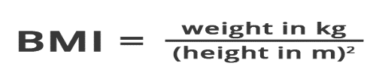

| The standard weight status categories associated with BMI ranges for adults are shown in the following table. | |
| --- | --- |
| **BMI** | **Weight Status** |
| Below 18.5 | Underweight |
| 18.5 – 24.9 | Healthy Weight |
| 25.0 – 29.9 | Overweight |
| 30.0 and Above | Obesity |

The science behind weight management is complex, but one of the key concepts that govern weight management is [Energy Balance](https://en.wikipedia.org/wiki/Energy_homeostasis)**.** Energy Balance is the phrase used to describe the difference between the number of [calories](https://en.wikipedia.org/wiki/Calorie) a person consumes and the number of calories that same person expends (a.k.a. burns) in a given time period. The calories a person consumes come from both the foods and drinks they eat and drink. The calories a person expends comes from their basal metabolic rate and their daily physical activity.

When eating a healthy diet mainly composed of vegetables, lean meats, and fruits, the human body is very good at maintaining a neutral energy balance so that calories consumed do not substantially exceed calories expended in a given time period and vice versa. This unconscious regulation of energy balance is one of the factors that make sustained weight loss very difficult for many people. That being said, consuming fewer calories than the number of calories expended each day is fundamental to weight loss in both the short and long term.

**Activity1: My Daily Meal Log**

**Directions:** Using the Daily Meal Log, fill in your meals for five consecutive days.

|  |  |  |  |  |  |
| --- | --- | --- | --- | --- | --- |
| Meals | Day 1 | Day 2 | Day 3 | Day 4 | Day 5 |
| Breakfast | Egg and Rice | Bread & Coffee | Egg and Rice | Bread & Boku juice | Egg & Fried Rice |
| AM Snack  (if applicable) | Boku juice |  | Yakult |  |  |
| Lunch | Nilagang Baboy | Sinigang na Hipon | Adobong Baboy | Fried Chicken | Fried Shrimp |
| PM Snack  (if applicable) | Bread and juice | Mami pares | Mami pares |  | Bread and juice |
| Dinner | Corned beef & egg | Ichiban Ramen | Fried Shrimp | Century Tuna | Nilagang Baboy |
| Snack  (if applicable) |  | Yakult | Yakult | Bread |  |
| Specific cravings | Yakult | C2 juice | Shrimp | Yakult | Yakult |

**Activity 2: Monthly Physical Activity Log**

**Directions:** Complete the worksheet.

|  |  |  |  |  |  |  |  |
| --- | --- | --- | --- | --- | --- | --- | --- |
| Week No. | SUN | MON | TUE | WED | THU | FRI | SAT |
| 1 | Plank |  |  |  |  |  |  |
| 2 |  |  |  |  |  |  |  |
| 3 |  |  |  |  |  |  |  |
| 4 |  |  |  |  |  |  |  |

**Activity 3: My Sleeping Pattern**

**Directions**: In this activity, you need to record the time you sleep and the time you wake up for a month.

Month of ___________________________

|  |  |  |  |  |  |  |  |
| --- | --- | --- | --- | --- | --- | --- | --- |
| Week No. | SUN | MON | TUE | WED | THU | FRI | SAT |
| 1 |  |  |  |  |  |  |  |
| 2 |  |  |  |  |  |  |  |
| 3 |  |  |  |  |  |  |  |
| 4 |  |  |  |  |  |  |  |

**Activity 4: Think and Share**

**Directions**: Read and understand the concepts below. You can raise questions that you want to clarify where students and teachers must collaborate in this part.

**Activity 5: Computing the Body Mass Index**

|  |  |  |  |  |
| --- | --- | --- | --- | --- |
| **Group Members** | **Weight(kg)** | **Height(m)** | **BMI** | **Weight Status** |
| **1** |  |  |  |  |
| **2** |  |  |  |  |
| **3** |  |  |  |  |
| **4** |  |  |  |  |
| **5** |  |  |  |  |

**Module No. 12**

**Week 14**

One of the best tips may be to completely ignore claims on the front of the packaging. Front labels try to lure you into purchasing products by making health claims. In fact, research shows that adding health claims to front labels makes people believe a product is healthier than the same product that doesn’t list health claims — thus affecting consumer choices.

Manufacturers are often dishonest in the way they use these labels. They tend to use health claims that are misleading and, in some cases, downright false.

Despite what the label may imply, these products are not healthy.

This makes it hard for consumers to choose healthy options without a thorough inspection of the ingredients list.

1. Things to Consider in Reading the Labels
2. **Study the Ingredients List**

Product ingredients are listed by quantity-from highest to lowest amount.

This means that the first ingredient is what the manufacturer used the most.

A good rule of thumb is to scan the first three ingredients, as they make up the largest part of what you’re eating. If the first ingredients include [refined grains](https://www.healthline.com/nutrition/why-refined-carbs-are-bad), a type of sugar, or hydrogenated oils, you can assume that the product is unhealthy. Instead, try choosing items that have whole foods listed as the first three ingredients. In addition, an ingredients list that is longer than two to three lines suggests that the product is highly processed.

1. **Watch out for Serving Sizes**

Nutrition labels state how many [calories](https://www.healthline.com/nutrition/how-many-calories-per-day) and nutrients are in a standard amount of the product-often a suggested single serving. However, these serving sizes are frequently much smaller than what people consume in one sitting.

For example, one serving maybe half a can of soda, a quarter of a cookie, half a chocolate bar, or a single biscuit. In doing so, manufacturers try to deceive consumers into thinking that the food has fewer calories and less sugar.

Many people are unaware of this serving size scheme, assuming that the entire container is a single serving, when in truth it may consist of two, three, or more servings. If you’re interested in knowing the nutritional value of what you’re eating, you need to multiply the serving given on the back by the number of servings you consumed.

1. **The Most Misleading Claims**

Health claims on packaged food are designed to catch your attention and convince you that the product is healthy.

Here are some of the most common claims — and what they mean:

* **Light.** Light products are processed to reduce either calories or fat. Some products are simply watered down. Check carefully to see if anything has been added instead — like sugar.
* **Multigrain.** This sounds very healthy but only means that a product contains more than one type of [grain](https://www.healthline.com/nutrition/grains-good-or-bad). These are most likely refined grains — unless the product is marked as whole grain.
* **Natural.** This does not necessarily mean that the product resembles anything natural. It simply indicates that at one point the manufacturer worked with a natural source like apples or rice.
* **Organic.** This label says very little about whether a product is healthy. For example, organic sugar is still sugar.
* **No added sugar.**Some products are naturally high in sugar. The fact that they don’t have added sugar doesn’t mean they’re healthy. Unhealthy sugar substitutes may also have been added.
* **Low-calorie.** Low-calorie products have to have one-third fewer calories than the brand’s original product. Yet, one brand’s low-calorie version may have similar calories as another brand’s original.
* **Low-fat.** This label usually means that the fat has been reduced at the cost of adding more sugar. Be very careful and read the ingredients list.
* **Low-carb.** Recently, [low-carb diets](https://www.healthline.com/nutrition/low-carb-diet-meal-plan-and-menu) have been linked to improved health. Still, processed foods that are labeled low-carb are usually still processed junk foods, similar to processed low-fat foods.
* **Made with whole grains.** The product may contain very little whole grains. Check the ingredients list — if whole grains aren’t in the first three ingredients, the amount is negligible.
* **Fortified or enriched.** This means that some nutrients have been added to the product. For example, vitamin D is often added to milk. Yet, just because something is fortified doesn’t make it healthy.
* **Gluten-free.** [Gluten-free](https://www.healthline.com/nutrition/gluten-free-diet-101) doesn’t mean healthy. The product simply doesn’t contain wheat, spelt, rye, or barley. Many gluten-free foods are highly processed and loaded with unhealthy fats and sugar.
* **Fruit-flavored.** Many processed foods have a name that refers to a natural flavor, such as strawberry yogurt. However, the product may not contain any fruit — only chemicals designed to taste like fruit.
* **Zero trans fat.** This phrase means “less than 0.5 grams of trans fat per serving.” Thus, if serving sizes are misleadingly small, the product may [still contain trans fat](https://www.healthline.com/nutrition/trans-fat-foods).

1. **Different Names for Sugar**

Sugar goes by [countless names](https://www.healthline.com/nutrition/56-different-names-for-sugar) — many of which you may not recognize. Food manufacturers use this to their advantage by purposely adding many different types of sugar to their products to hide the actual amount.

In doing so, they can list a healthier ingredient at the top, mentioning sugar further down. So even though a product may be loaded with sugar, it doesn’t necessarily appear as one of the first three ingredients.

To avoid accidentally consuming a lot of sugar, watch out for the following names of sugar in ingredient lists:

* **Types of sugar:** beet sugar, brown sugar, buttered sugar, cane sugar, caster sugar, coconut sugar, date sugar, golden sugar, invert sugar, muscovado sugar, organic raw sugar, raspadura sugar, evaporated cane juice, and confectioner’s sugar.
* **Types of syrup:** carob syrup, golden syrup, [high-fructose corn syrup](https://www.healthline.com/nutrition/high-fructose-corn-syrup-vs-sugar), honey, agave nectar, malt syrup, maple syrup, oat syrup, rice bran syrup, and rice syrup.
* **Other added sugars:** barley malt, molasses, cane juice crystals, lactose, corn sweetener, crystalline fructose, dextran, malt powder, ethyl maltol, fructose, fruit juice concentrate, galactose, glucose, disaccharides, maltodextrin, and maltose.

1. **The Bottom Line**

The best way to avoid being misled by product labels is to avoid processed foods altogether. After all, [whole food](https://www.healthline.com/nutrition/21-reasons-to-eat-real-food) doesn’t need an ingredients list.

Still, if you decide to buy packaged foods, be sure to sort out the junk from the higher-quality products with the helpful tips in this article.

1. Fad Diets

Many fad diets promote quick weight loss without taking into effect the nutrients your body needs. These weight loss plans rarely help you over the long haul — and some can even cause health problems. Here’s how to identify a fad diet.

Fad diets are plans sold as the best and fastest approach to losing weight. Yet some of these diets involve eliminating foods that contain necessary nutrients that your body needs to maintain good health. Some diets claim particular hormones are to blame for weight gain, suggesting that food can change body chemistry. Often these diets aren’t well researched, or the research is faulty.

These are the kinds of diets that you often see endorsed by celebrities or promoted through media. Some hype particular foods like cabbage, foods that contain [probiotics](https://my.clevelandclinic.org/health/articles/14598-probiotics), or raw foods. Or they may include high-fat, low-carbohydrate, or high-protein diets. They eliminate important sources of nutrition, such as grains. Or they eliminate certain ingredients, such as lectins.

Some have you eliminate certain foods at specific times of the day. Others allow you certain foods, as long as you eat them along with certain other foods.

Although some diets may be recommended in special situations, many of these may lack major nutrients, such as dietary fiber and carbohydrates, as well as selected vitamins, minerals, and protective phytochemicals. By not receiving the right amounts of these nutrients, you can develop serious health problems.

All fad diets have one thing in common: They propose a temporary solution to what for many people is a lifelong problem. Once the diet is stopped, the lost weight is usually regained quickly. Fad diets don’t focus on lifestyle modification, which is necessary to keep the weight off, and these diets aren’t sustainable throughout life.

### How do I spot a fad diet?

There isn’t a set approach to spotting a fad diet, but these general tips can help. Fad diets tend to have:

* Recommendations that promise a quick fix.
* Claims that sound too good to be true.
* Simplistic conclusions are drawn from a complex study.
* Recommendations based on a single study.
* Dramatic statements that are refuted by reputable scientific organizations.
* Lists of "good" and "bad" foods.
* Recommendations made to help sell a book or product.
* Recommendations based on studies published without peer review.
* Recommendations from studies that ignore differences among individuals or groups.
* Elimination of one or more of the five food groups (fruits, vegetables, grains, protein foods, and dairy) or subgroups (grains, dairy, fruit).
* Diets that have “testimonials.”

**What is still the best method to lose weight and keep it off?**

Exercise regularly and eat a variety of unprocessed or minimally processed foods with moderate portions.

**Activity1: What is Our Label?**

**Directions:** Look for the label of your favorite food/snack, cut it, and paste it here. Kindly list down the effect of your selected ingredients (at least 3) on your health in relation to weight management.

|  |
| --- |
| STICK IT HERE: Effect of Ingredients:  Justin Kiness on Twitter: "Okay so a typical Nestlé Milo sachet (24 g) ay  for 0.10 L or 100 mL of water lang pala. Kaya pala wala talagang lasa kapag  pinupuno mo '  **Cacao**: chocolate sweetener  **Milk powder**: added milk flavor  **Sugar**: sweetener  **Sodium phosphate**: added saltiness  **Artificial flavour**: added flavor |

**Activity 2: CLAIMS, CLAIMS, AND CLAIMS!**

**Direction:** Look for the top five food products and give their famous tag lines that relate to their products.

|  |  |
| --- | --- |
| PRODUCT NAME | FAMOUS TAG/MARKETING LINE |
| Yakult | **"OK ka ba tiyan?"** |
| Rebisco | **“Delight in the World of Endless Possibilities”** |
| Bear Brand | **"Tibay Araw-Araw"** |
| Milo | **"Great things start from small beginnings."** |
| Alaska Milk | **“Wala paring tatalo sa Alaska.”** |

**Activity 3: Think and Share**

**Directions**: Read and understand the concepts below. You can raise questions that you want to clarify where students and teachers must collaborate in this part.

**Activity 4: List down popular diet programs promoted by celebrities and well-known individuals in our society today. Cite some harmful effects of the said fad diet.**

|  |  |
| --- | --- |
| **FAD DIETS** | **HARMFUL/SIDE EFFECTS** |
| **1** Cobra Energy Drink | **Dangurous energy drink** |
| **2** Lucky Me! Noodles | **Too many preservatives** |
| **3** Pop Cola | **Junk foods** |
| **4** Red Horse Beer | **Alcoholic** |
| **5** Piattos | **Too many chemicals** |

**Module No. 13**

**Week 15**

**ACTIVITY 1: PINGGANG PINOY**

**Direction: Mention some different food that will fall under each part of the suggested “PINGGANG PINOY”**



|  |  |  |
| --- | --- | --- |
| *Go* | *Grow* | *Glow* |
| Tinapay, kanin, pasta, Kamote, patatas, prutas, honey, at sweet corn | baboy, isda, itlog, green pease, beans, mani, gatas, keso at yogurt | Gatas, keso, Soymilk, soybeans, tokwa, taho, Isda at karne ng baboy |

**ACTIVITY 2: Sorting Out**

**DIRECTION:** Group the following words based on the category below.

|  |  |  |
| --- | --- | --- |
| *Go* | *Grow* | *Glow* |
| RICE POULTRY RED MEAT FISH OATMEAL MANGO ORANGES PAPAYA PASTA PINEAPPLE EGGS BANANA BERRIES GRAPES BREAD | | |

|  |  |  |
| --- | --- | --- |
| *Go* | *Grow* | *Glow* |
| OATMEAL | EGGS | GRAPES |
| BREAD | FISH | BERRIES |
| PASTA | RED MEAT | BANANA |
| RICE | POULTR | PINEAPPLE |
|  |  | PAPAYA |
|  |  | ORANGES |
|  |  | MANGO |

**ACTIVITY 3: Food Pyramid**

**Direction:** Create your ideal food pyramid.

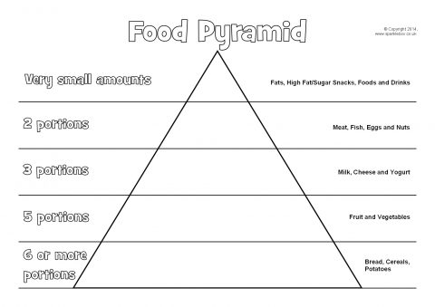

**QUESTIONS:**

1. What portion do you need the most? why?

* Bread, Cereals, Potatoes

2. What portion do you need least needed?

* Fats, High Fat/Sugar Snacks, Foods And Drinks

3. In which portion do you think water is included? Why?

* 5 Portions

4 What are the factors that you may consider that an individual cannot attain the ideal

food pyramid?

* Balance And Diet

5. how can an individual improve his/ her eating habit?

* Continually improving his/her diet and eating only nutritious meals, avoiding fatty foods

**ACTIVITY 4: PLAN WHAT YOU EAT**

**Direction:** Create a food plan essential to your needs

|  |  |  |  |  |  |  |  |
| --- | --- | --- | --- | --- | --- | --- | --- |
|  | *DAY 1* | *DAY 2* | *DAY 3* | *DAY 4* | *DAY 5* | *DAY 6* | *DAY 7* |
| *Breakfast* | Oatmeal | Toast | Apples | [Meaty Clubhouse Sandwich](https://www.ladyschoice.com.ph/recipes/meaty-clubhouse-sandwich.html) | [Tuna Sandwich](https://www.ladyschoice.com.ph/recipes/yummy-tuna-sandwich.html) | [Maki Sandwich](https://www.ladyschoice.com.ph/recipes/california-maki-sandwich.html) | [Tuna Melt Pie](https://www.ladyschoice.com.ph/recipes/tuna-melt-pie.html) |
| *Lunch* | Stir-Fried Tofu | Eggs | Spicy Buffalo Wings | [Grilled Chicken](https://www.ladyschoice.com.ph/recipes/grilled-chicken-salad-with-bbq-mayo-dressing.html) | [Fried Chicken Wings](https://www.ladyschoice.com.ph/recipes/fried-chicken-wings.html) | [Pork Bbq](https://www.ladyschoice.com.ph/recipes/pork-bbq-with-homemade-ranch-dressing.html) | [Lumpiang Shanghai](https://www.ladyschoice.com.ph/recipes/lumpiang-shanghai.html)With Rice |
| *Snack* | Nuts | Berries | [Creamy Macaroni Salad](https://www.ladyschoice.com.ph/recipes/creamy-macaroni-salad.html) | [Spaghetti Carbonara](https://www.ladyschoice.com.ph/recipes/spaghetti-carbonara.html) | [Spaghetti](https://www.ladyschoice.com.ph/recipes/best-creamy-pinoy-spaghetti.html) | [Macaroni Salad](https://www.ladyschoice.com.ph/recipes/creamy-macaroni-salad.html) | [Adobo Sandwich](https://www.ladyschoice.com.ph/recipes/adobo-sandwich.html) |
| *Dinner* | Curry Chicken | Spinach | [Pinoy Bistek](https://www.ladyschoice.com.ph/recipes/quick-pinoy-bistek.html) | [Pininyahang Manok](https://www.ladyschoice.com.ph/recipes/creamy-pininyahang-manok.html) | [Easy Baked Mussels](https://www.ladyschoice.com.ph/recipes/easy-baked-mussels.html) | [Tempura Salad](https://www.ladyschoice.com.ph/recipes/tempura-salad-with-wasabi-mayo-dressing.html) | [Fried Chicken Wings](https://www.ladyschoice.com.ph/recipes/fried-chicken-wings.html) |

**ACTIVITY 5: MY DAILY FOOD JOURNAL**

**Direction: review your food experiences from the past week and answer the following questions**



**Guide Question:**

* + - 1. **What do you think are the effects of what you eat?**
* **Obesity, weight gain, physical inactivity, stress, high blood pressure, high cholesterol, and obesity all raise the risk of heart disease and other malignancies.**
  + - 1. **Do you think it follows the suggested dietary plan for adults?**
* **makes healthy eating more understandable by providing a visual picture of the sorts of foods and beverages we should consume and in what quantities to maintain a healthy, balanced diet**
  + - 1. **If you have given a chance to each again the food that you had last week, do you want to eat the same food or you will go for healthier options? Why?**
* **Yes, Eating nutritious foods and remaining physically active will help you achieve and maintain a healthy weight and enhance your mood. Moving more and eating healthier may also help you keep up with the demands of your busy life and be present for those who rely on you.**

**Module No. 14**

**Week 16**

Physical Activity refers to an activity that involves the contraction of muscles- examples are gardening, walking, climbing stairs, etc. On the other hand, an exercise is a specific form of physical activity that is planned and structured involving repetitive bodily movements performed to improve and maintain physical fitness.

Exercise - physical activity that is planned, structured, and repetitive for the purpose of conditioning the body. The exercise consists of cardiovascular conditioning, strength and resistance training, and flexibility

Physical Fitness – is the set of goals that people have or achieve that is related to their ability to perform a physical activity

Levels of Physical Activity

1. Light intensity activity- such as walking slowly and gardening

2. Moderate Intensity activity- such as walking briskly, and playing leisure sports

3. Vigorous activity- such as jogging, running, playing competitive sports, and circuit training.

Rest - part of recovery. Recovery is everything that happens after the end of one workout and before the start of the next one. So, rest includes sleep, time for stillness—both mental and physical—as well as participation in activities that provide mental and/or physical rejuvenation

**Activity 1: What’s My Activity**

**Directions**: For the past week, List Down your Activities.

|  |  |  |  |  |  |  |
| --- | --- | --- | --- | --- | --- | --- |
| ***MONDAY*** | ***TUESDAY*** | ***WEDNESDAY*** | ***THURSDAY*** | ***FRIDAY*** | ***SATURDAY*** | ***SUNDAY*** |
| Jogging | Biking | Playing Basketball | Swimming | Dancing | Running | Pushups |

**Activity 2: Think and Interpret**

Directions: Using the information you got from the previous activity, try to provide answers to the questions below.

* + - 1. What are the moderate activities you have based on your answer in activity 1?
* Jogging and Playing Basketball
  + - 1. What are the vigorous activities you have based on your answer in activity 1?
* Running, Biking, and Swimming
  + - 1. Did you include a resting and recovery activity? Why do you think it is important?
* Yes it is important because body needs to recover and upgrade its muscles.

**Activity 4: Fill my Activity**

Directions: Fill in the Physical Activity Pyramid by writing Activities on each category.

Guide Questions:

1. Is it possible to do all the activities you have written on the pyramid?
   * Yes it is possible to do
2. As a college student how can you modify your own physical activities?
   * By shortening the time spend and making it more effective.
3. What do you think are the possible obstacles for you in doing physical activities?
   * Time, As college students we usually lack time to so somethings we want to do.

**Activity 6: My Physical Activity Log**

Directions: Log in your physical activities for the coming week. Use the format below.

**Physical Activity Diary**

Start date: 11/21/2022

|  |  |  |  |  |  |
| --- | --- | --- | --- | --- | --- |
| Day Of Week | Start Time | End Time | Type Of Activity | Location | Who With |
| Monday | 1 pm | 2 pm | Treadmill training | Gym | Myself |
| Tuesday | 2 pm | 3 pm | Played outside | Outside | With friends |
| Wednesday | 1 pm | 2 pm | Basketball | Outside | With friends |
| Thursday | 10 am | 11 am | Gym at home | Home | Myself |
| Friday | 4pm | 6 pm | Played outside | Outside | With friends |